<https://www.youtube.com/watch?v=KAtpB_WXLMY&list=PL5nViEmyYI0bmfcM_s4P-dfzKrOpcFWWK&index=24>

https://www.youtube.com/watch?v=8e5oQlxLluU&list=PL5nViEmyYI0bmfcM_s4P-dfzKrOpcFWWK&index=25

Install ansible -plugin related to build tool.

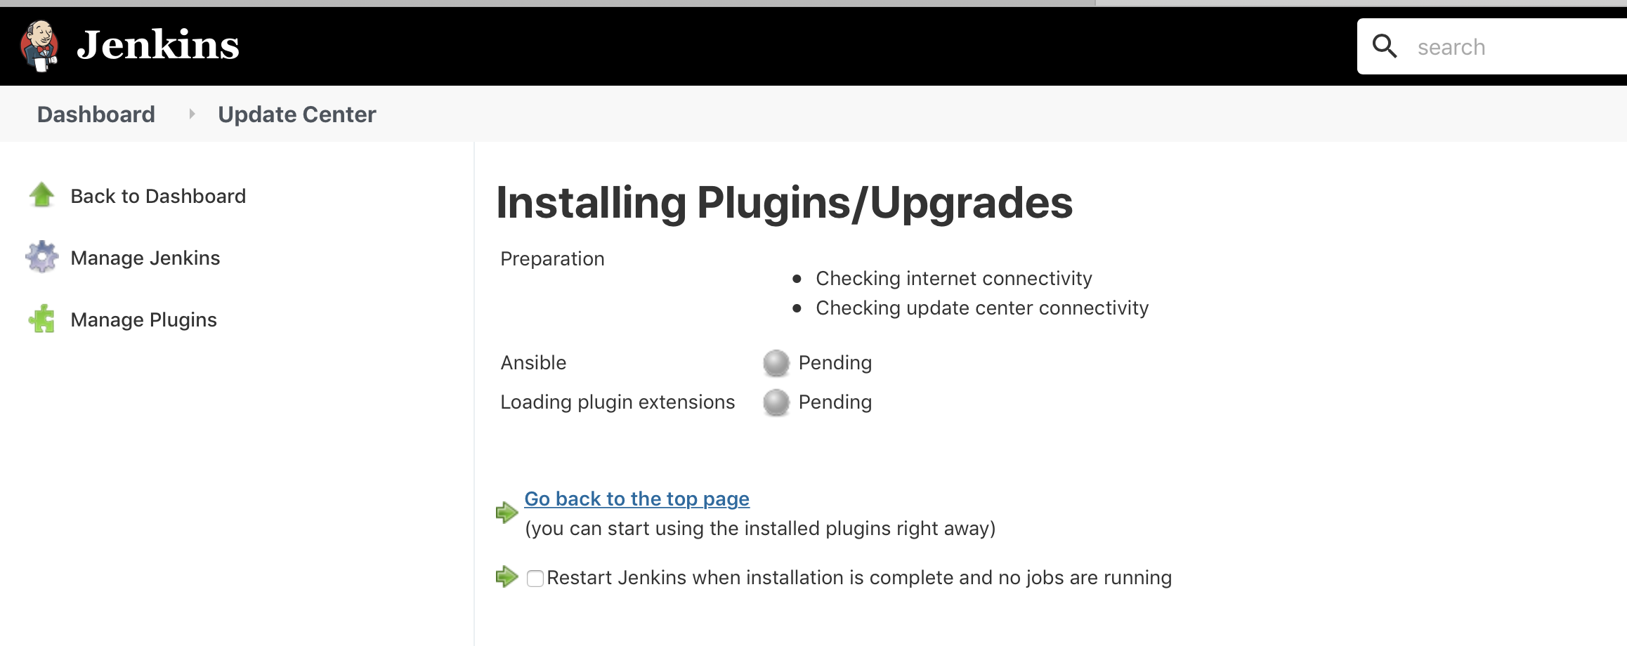

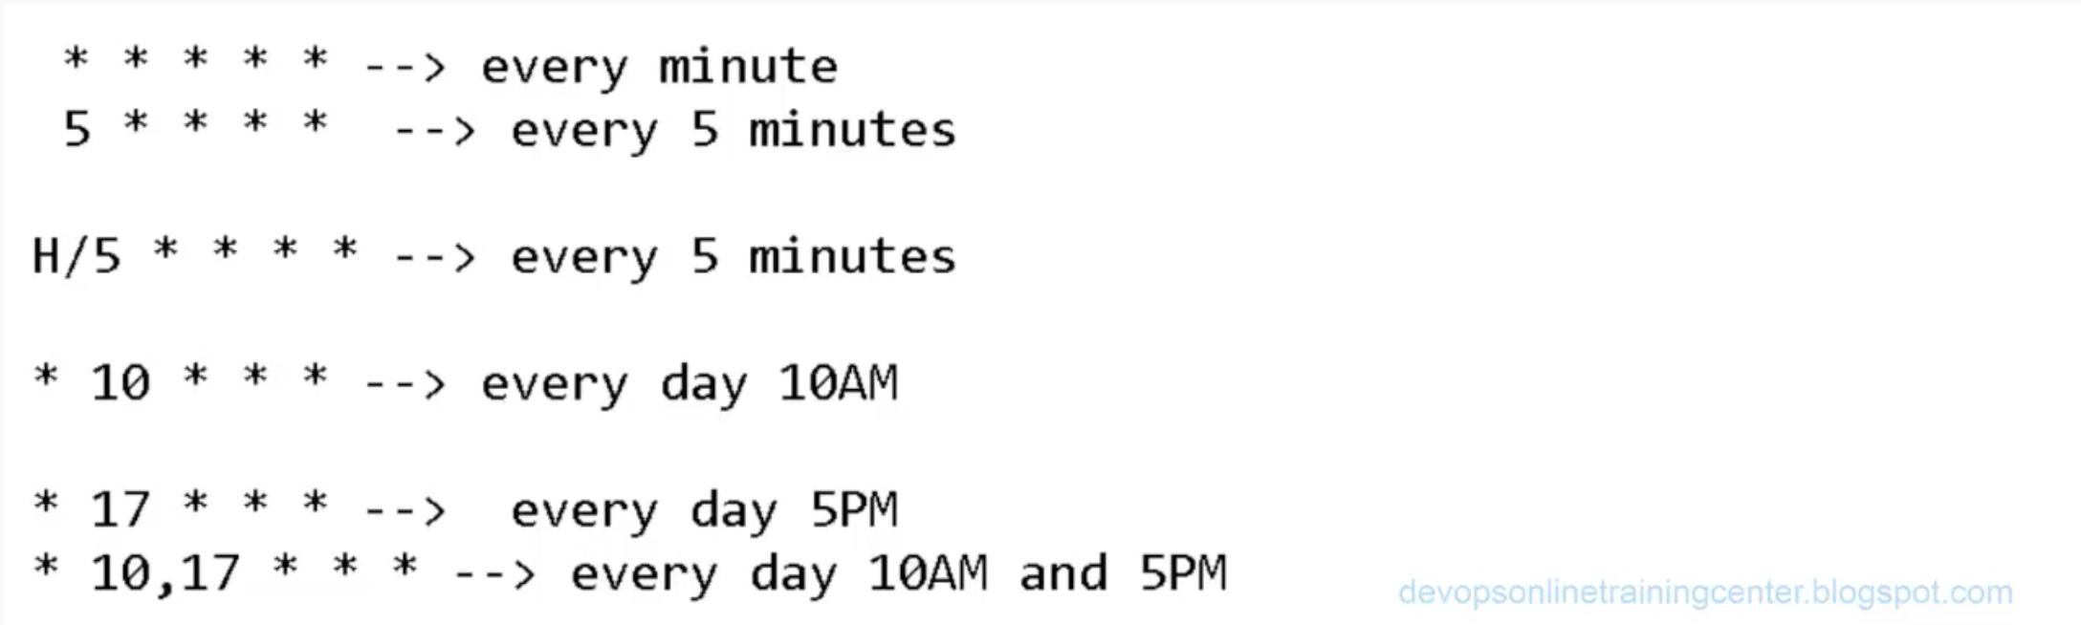

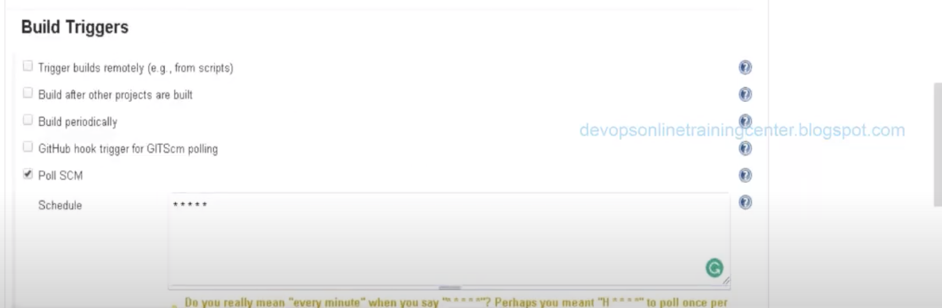

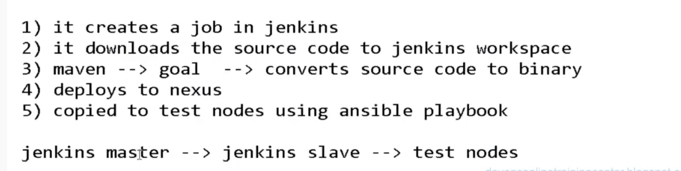



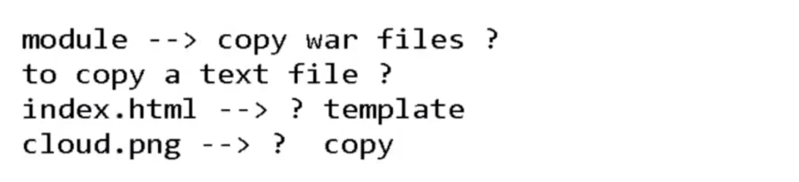

/etc/ansible/playbooks/sample.yaml

template: src=/var/lib/jenkins/workspace/jenkinsGithubMavenNexusAnsibleIntegration/target/gameoflife-web/gameoflife.war dest=/var/www/html/

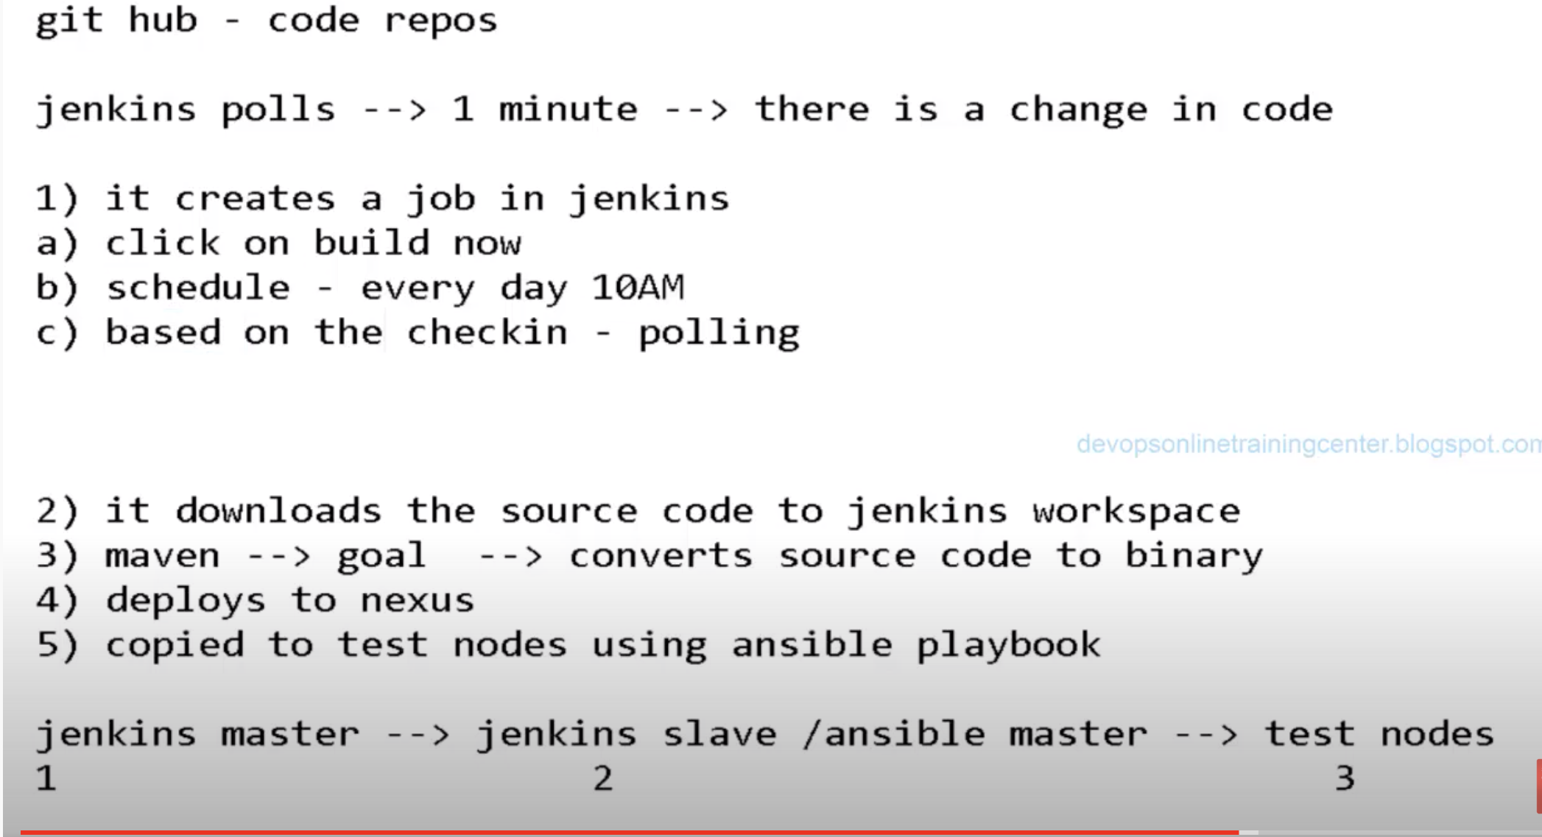

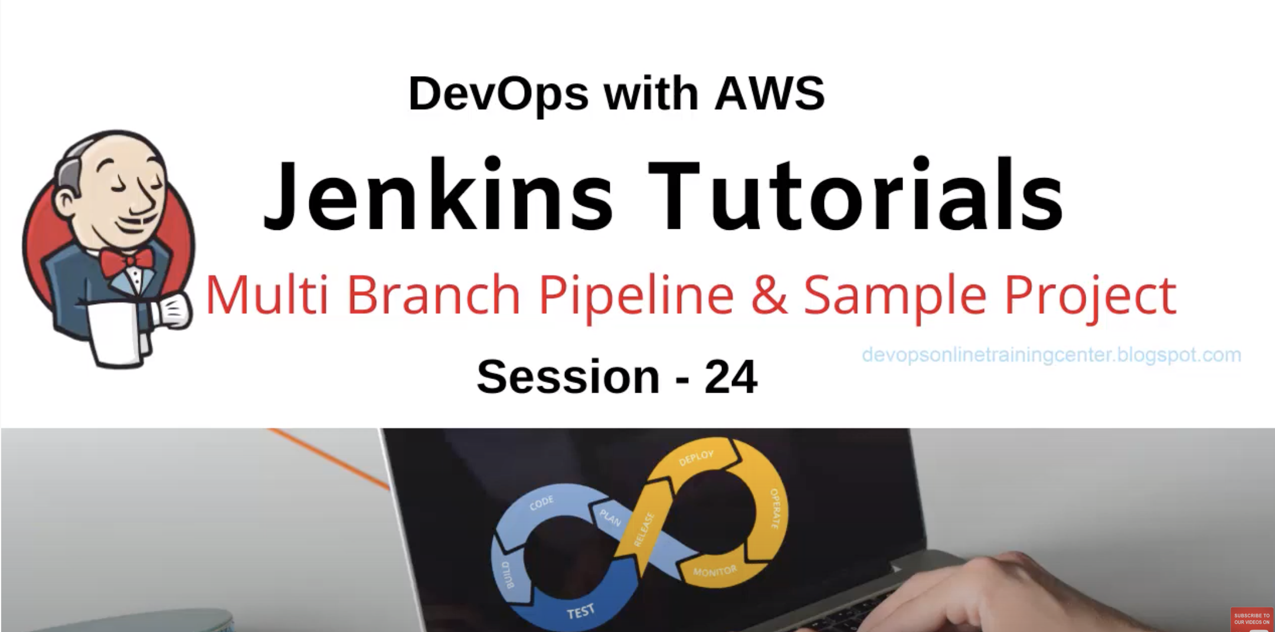

Sample scripts for jenkin pipeline.

node

{

stage 'download_from_github'

sh "echo download"

stage 'execute_tests'

sh "echo tests"

stage 'package'

sh "echo package"

stage 'deploy'

sh "echo deploy"

stage 'executeansible'

sh "echo ansible"

}

Download the code from GIT hub and execute via Jenkins:

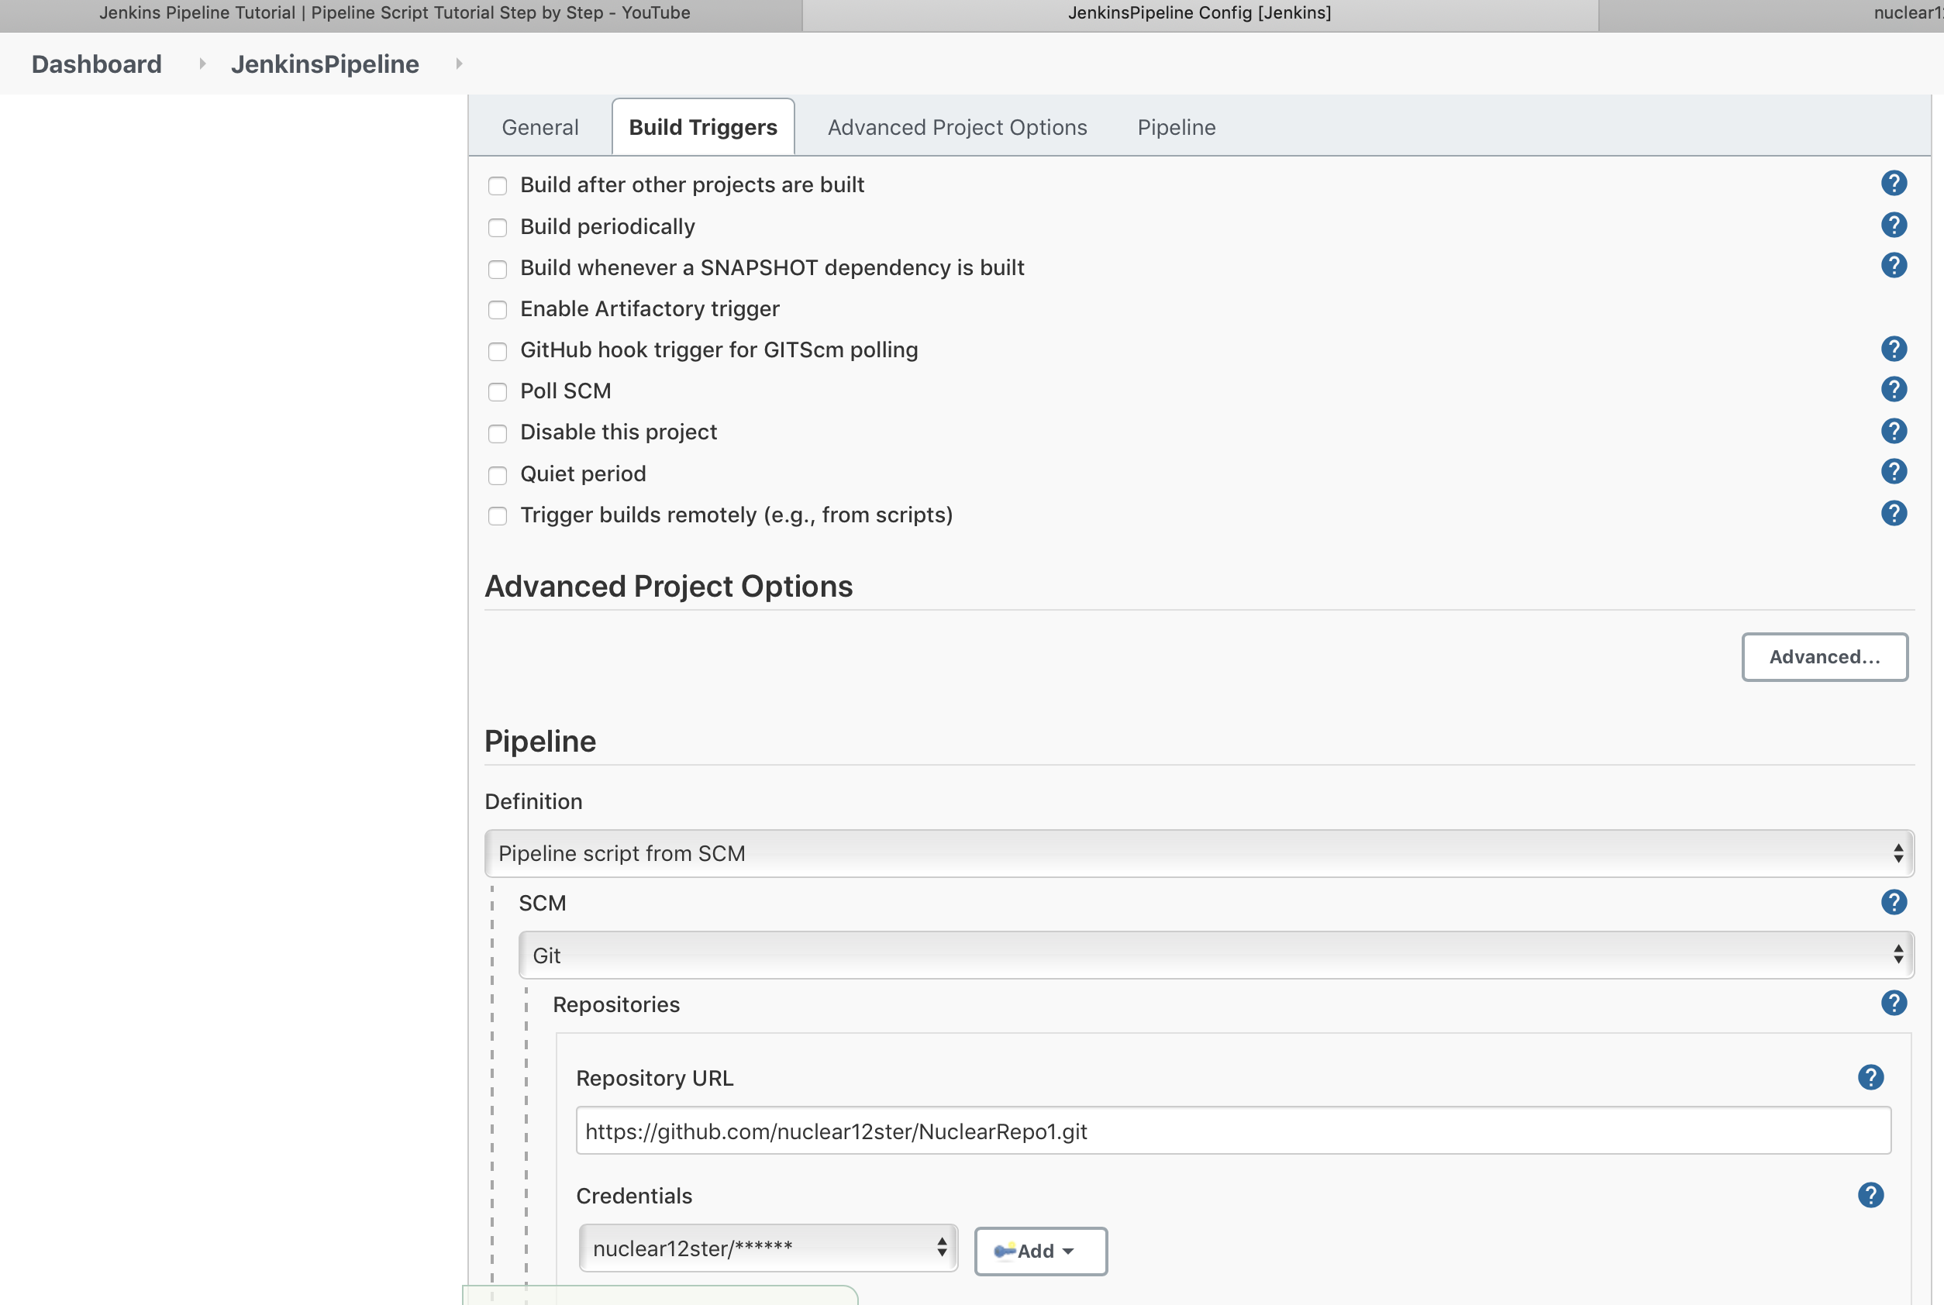

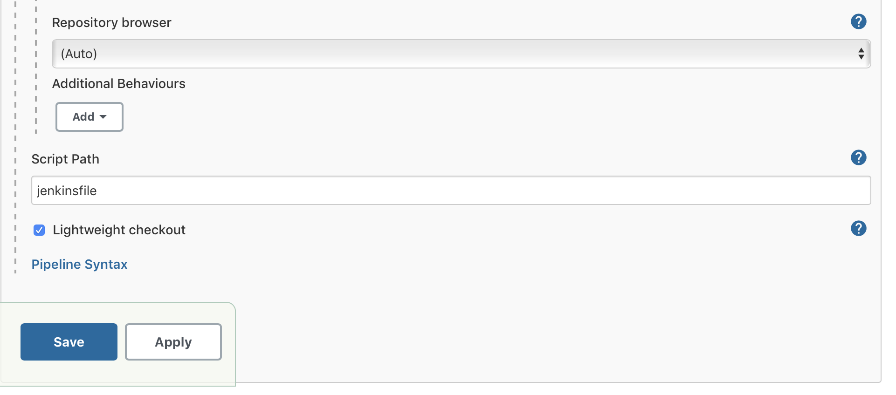

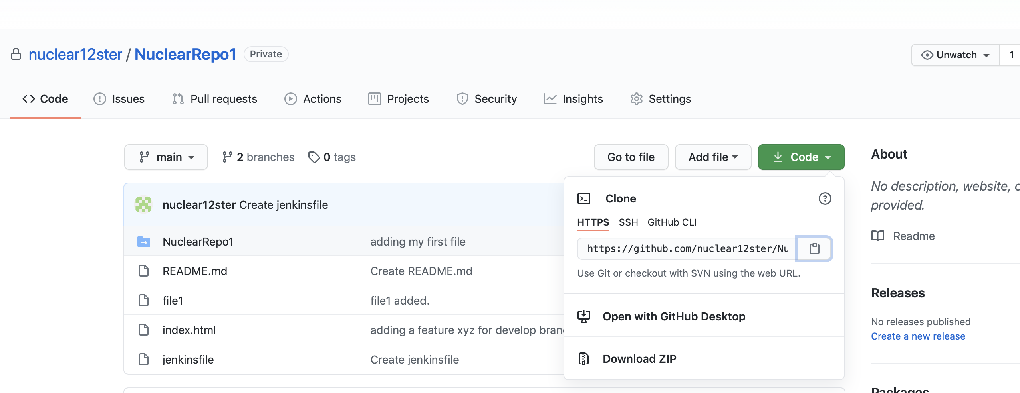

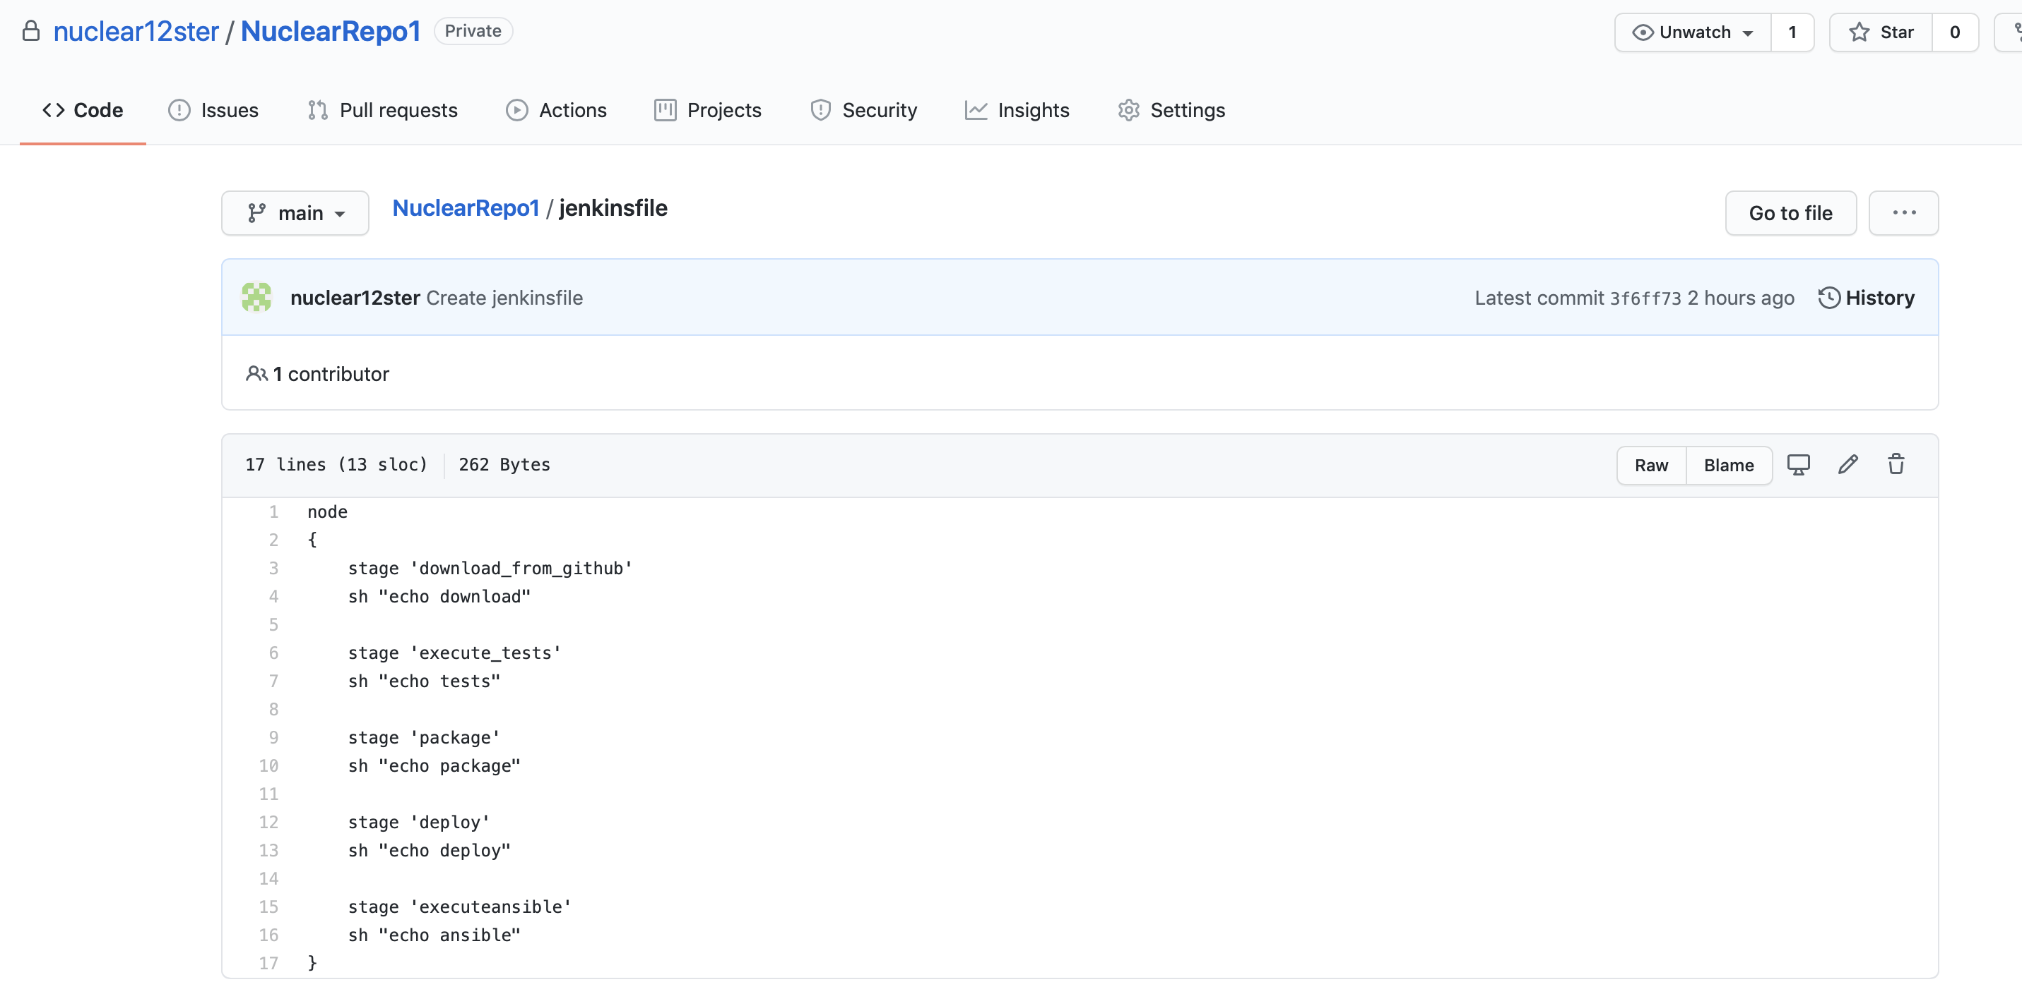

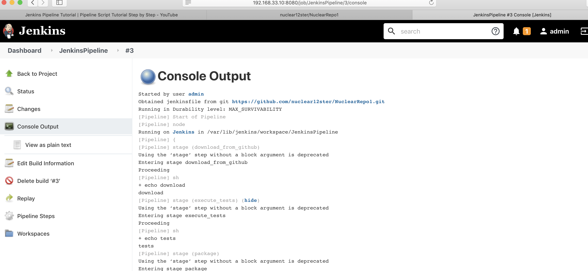

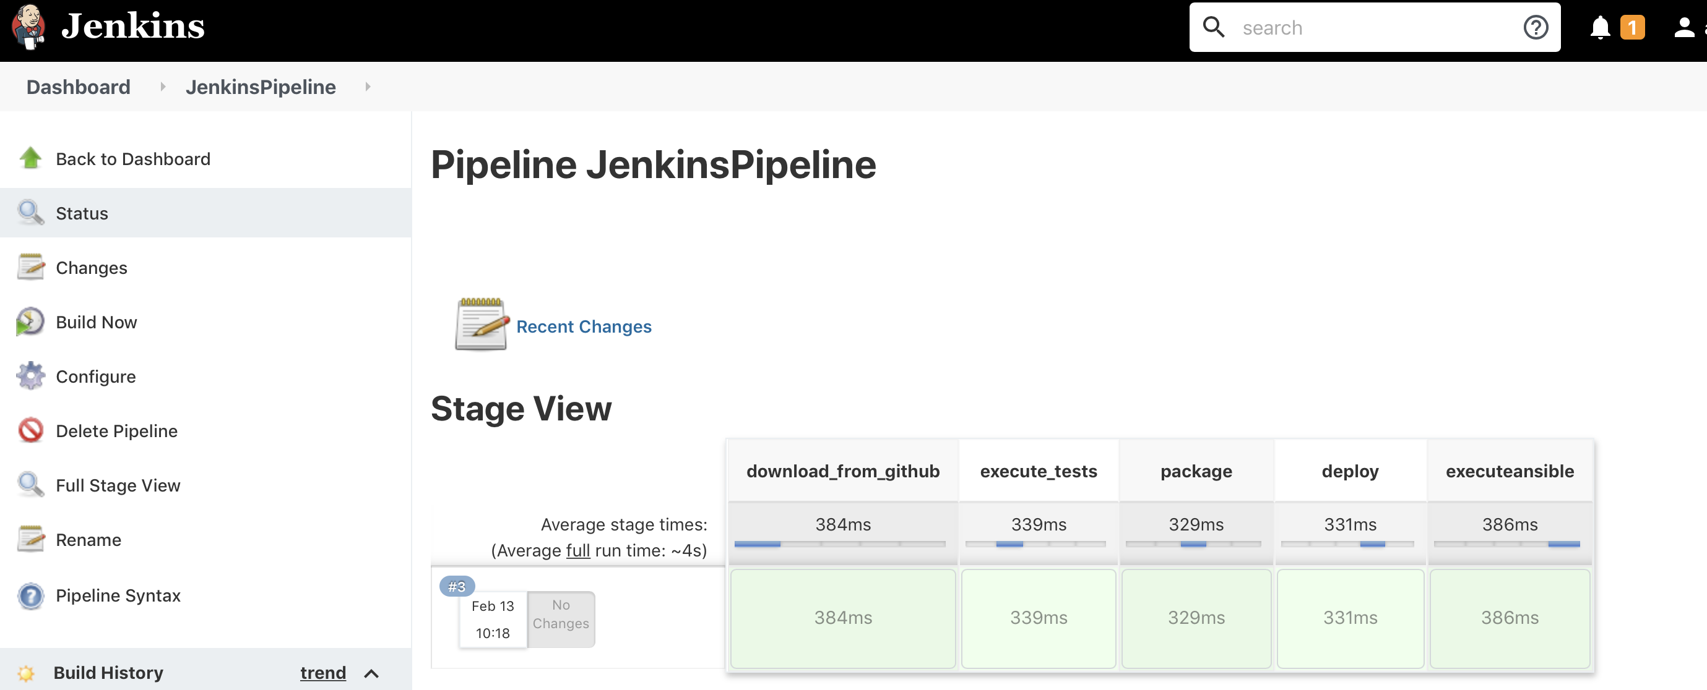

This is for any particular branch:

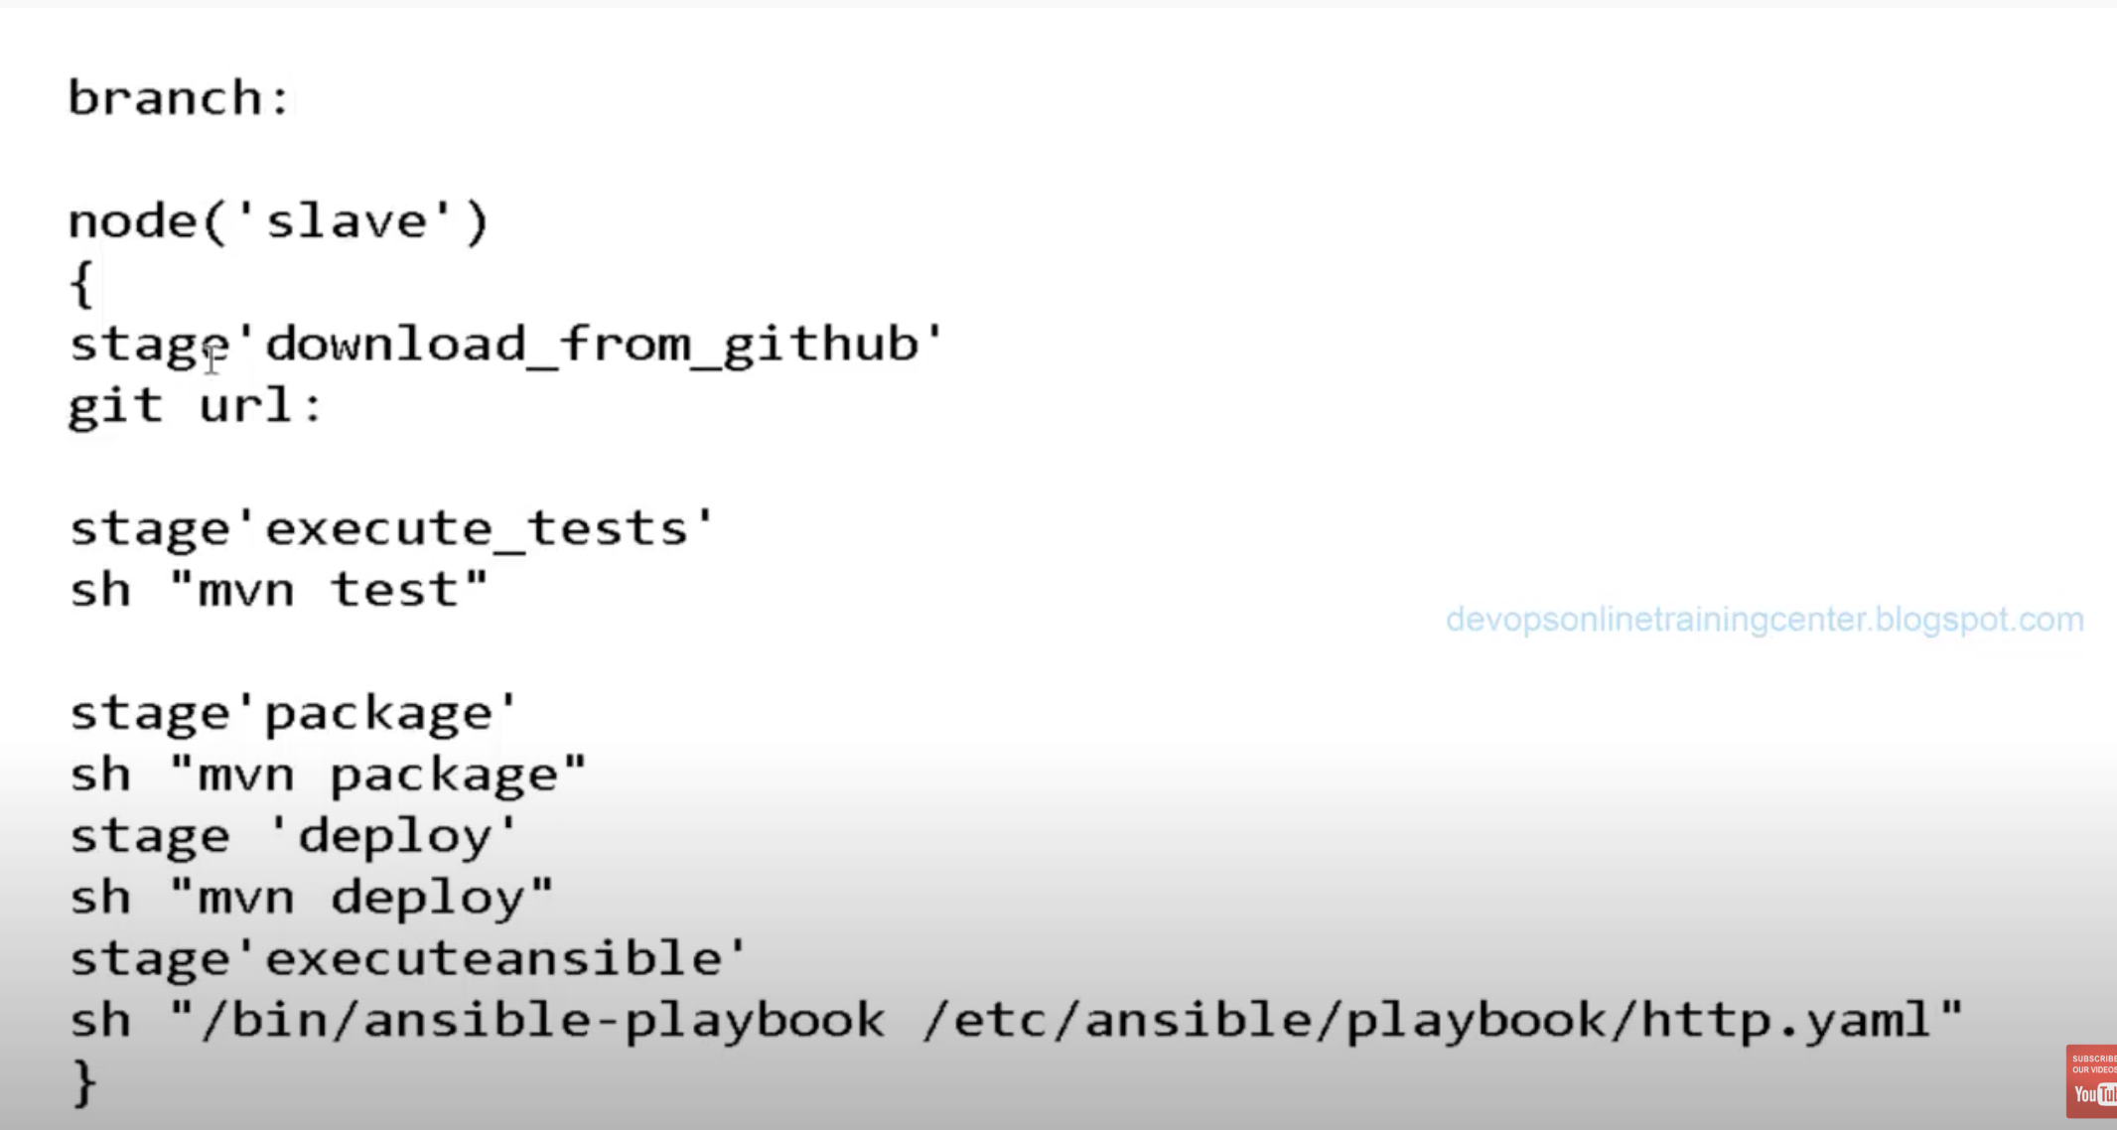

Multiple branch:

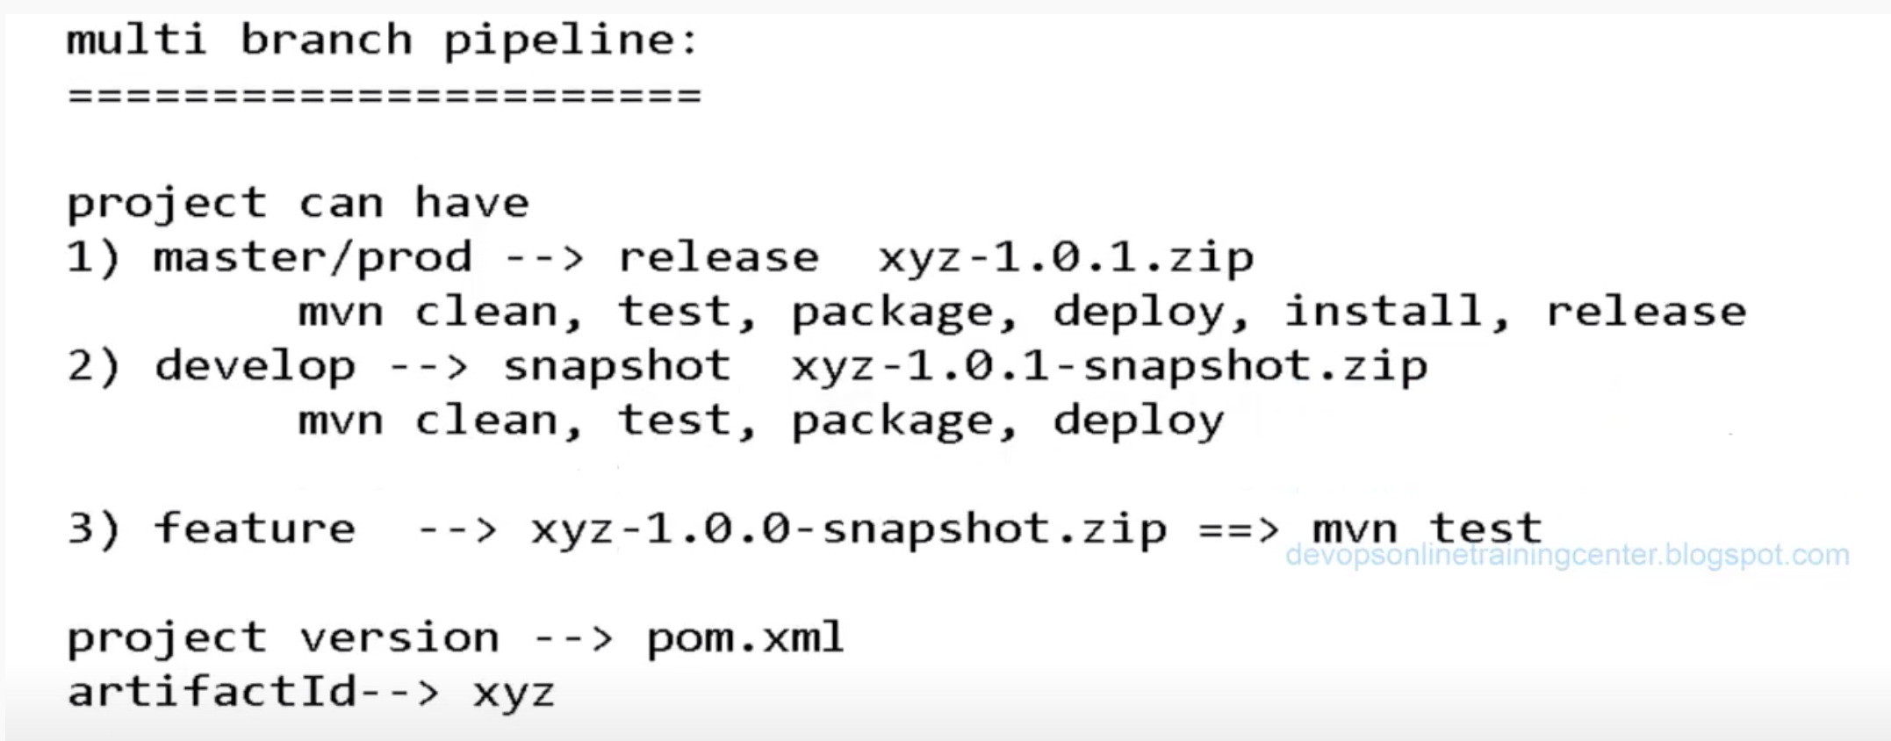

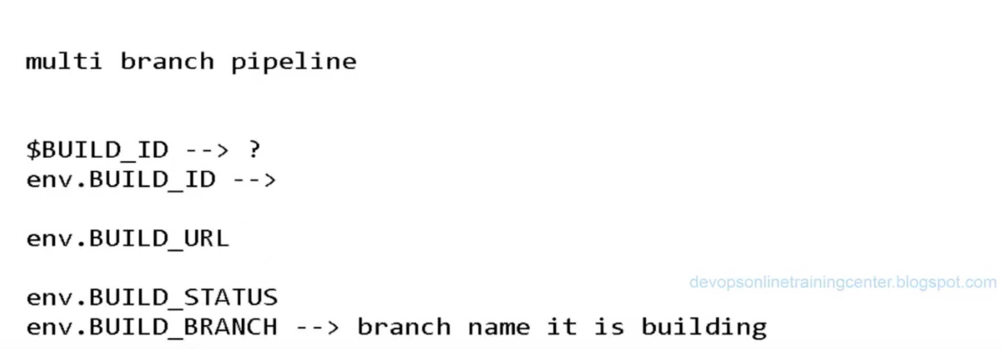

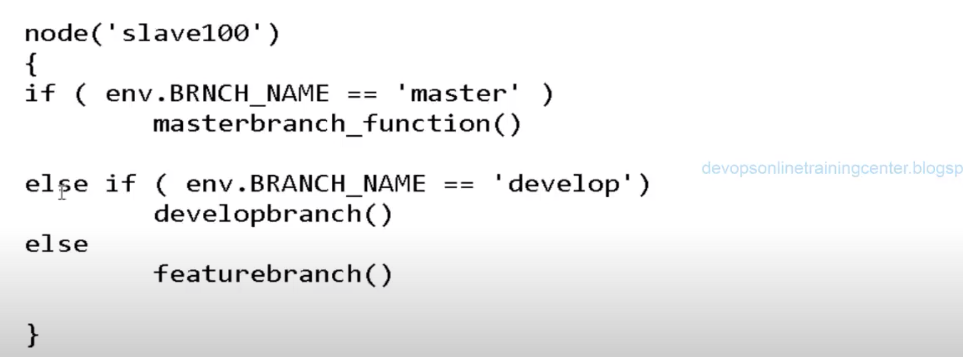

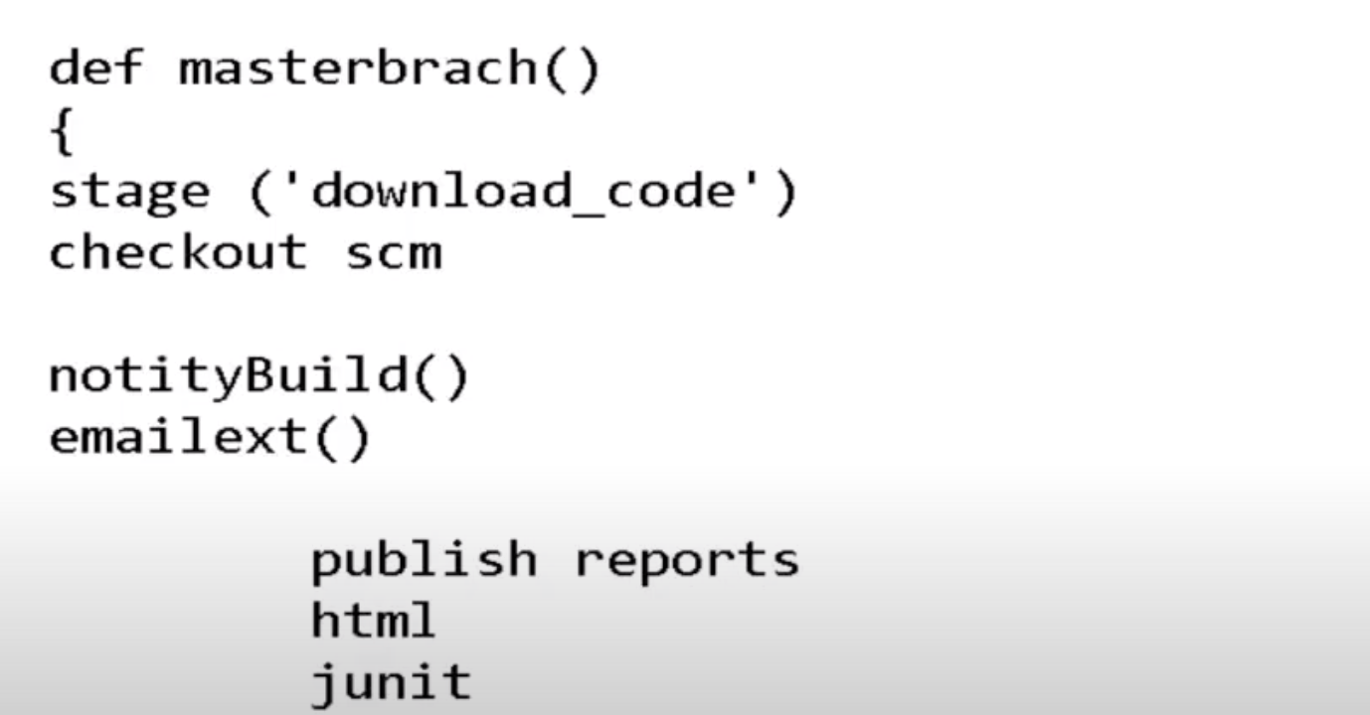

We have 2 branches and the branch which have Jenkinsfile will execute automatically.

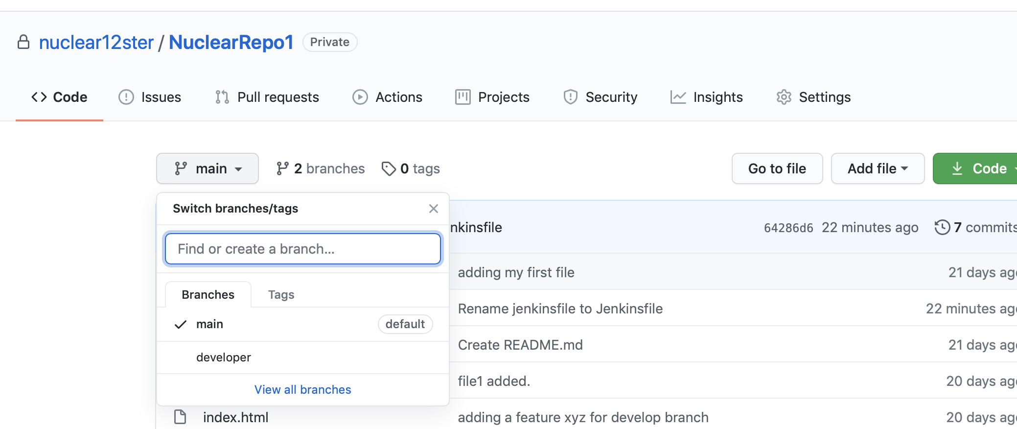

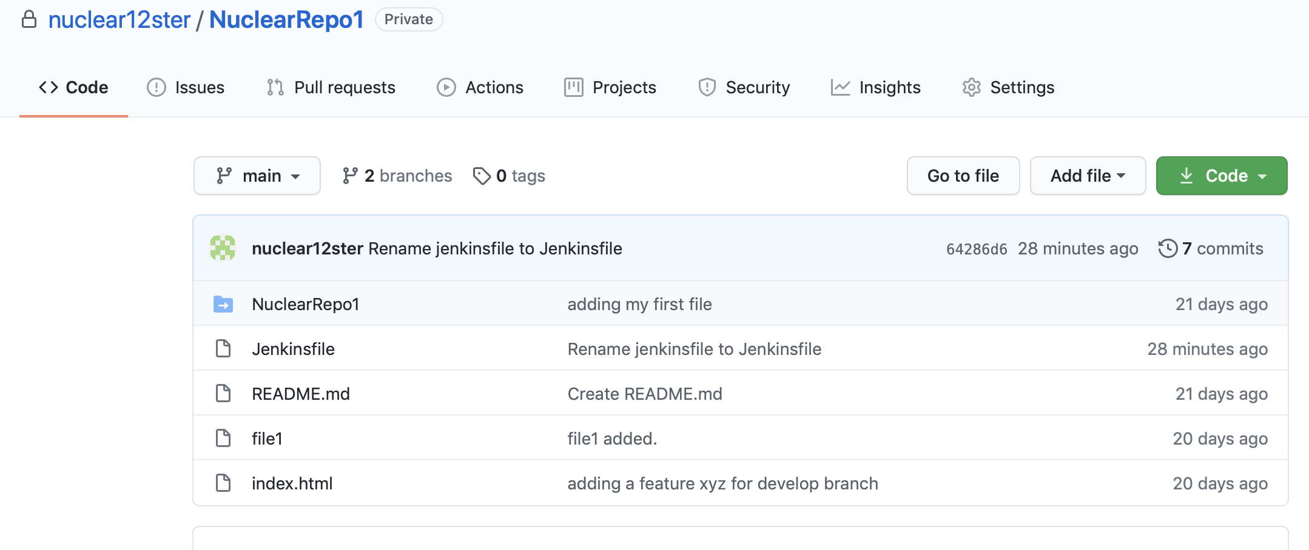

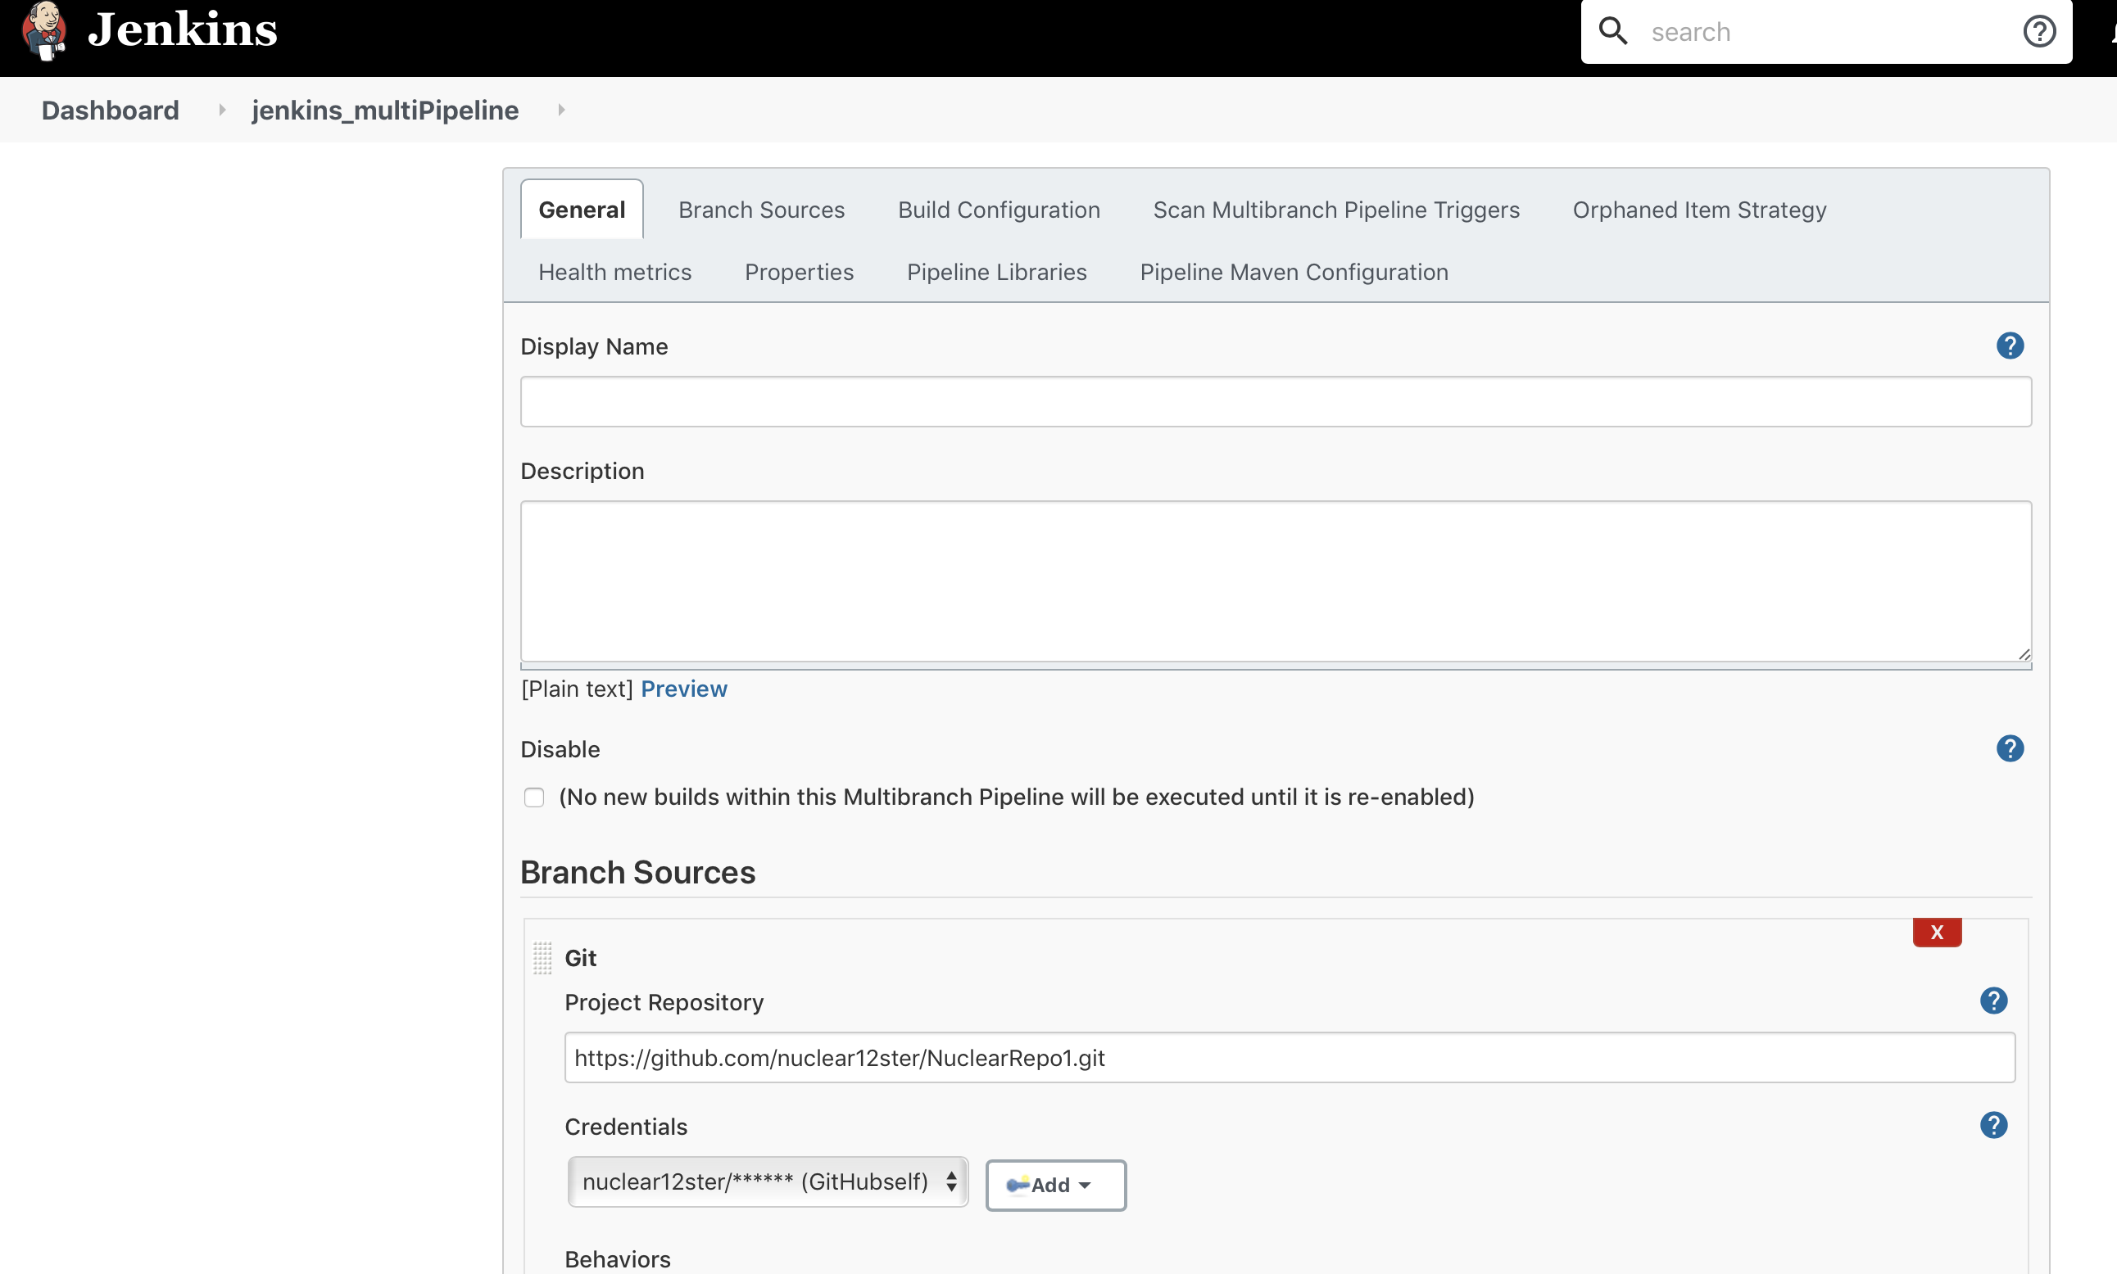

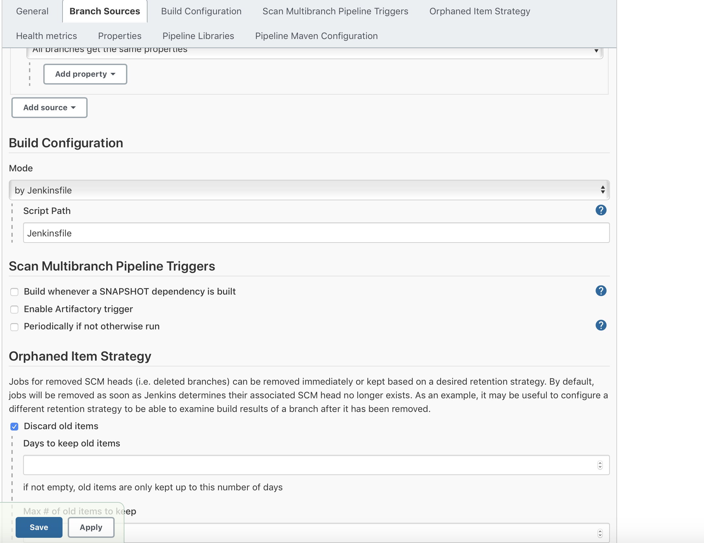

It will create the branch name “main”

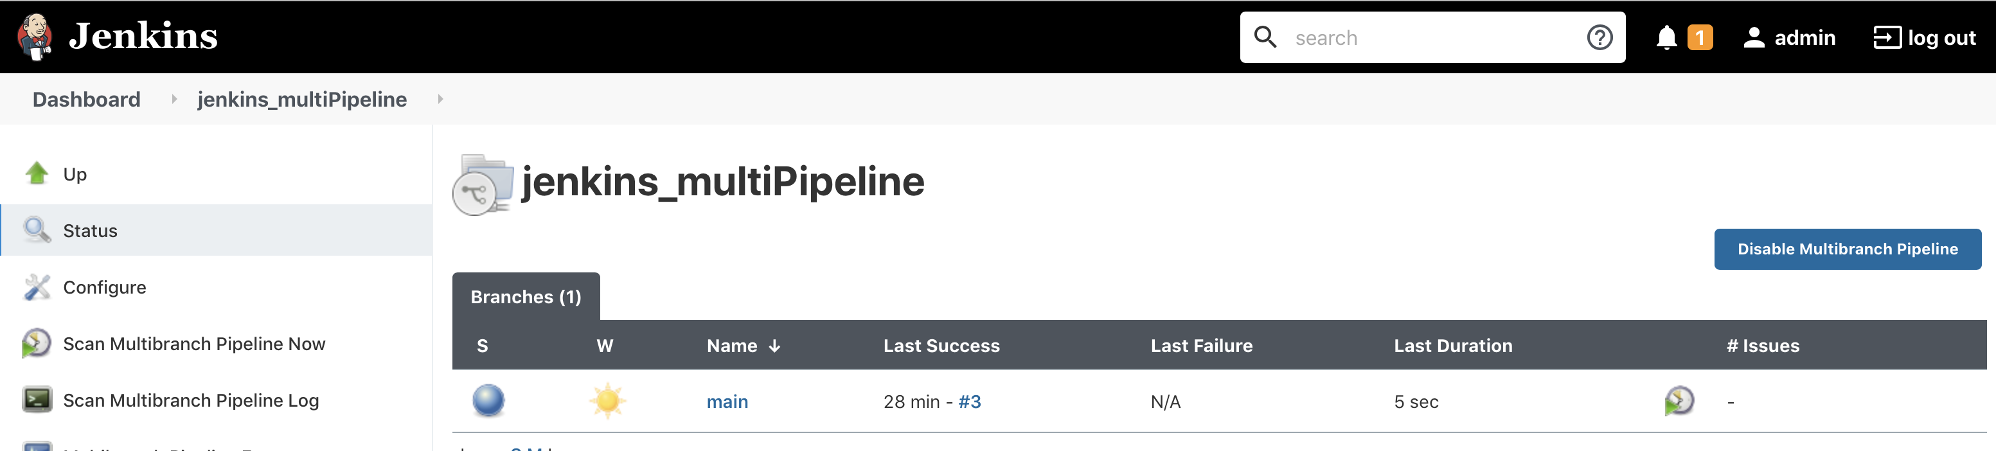

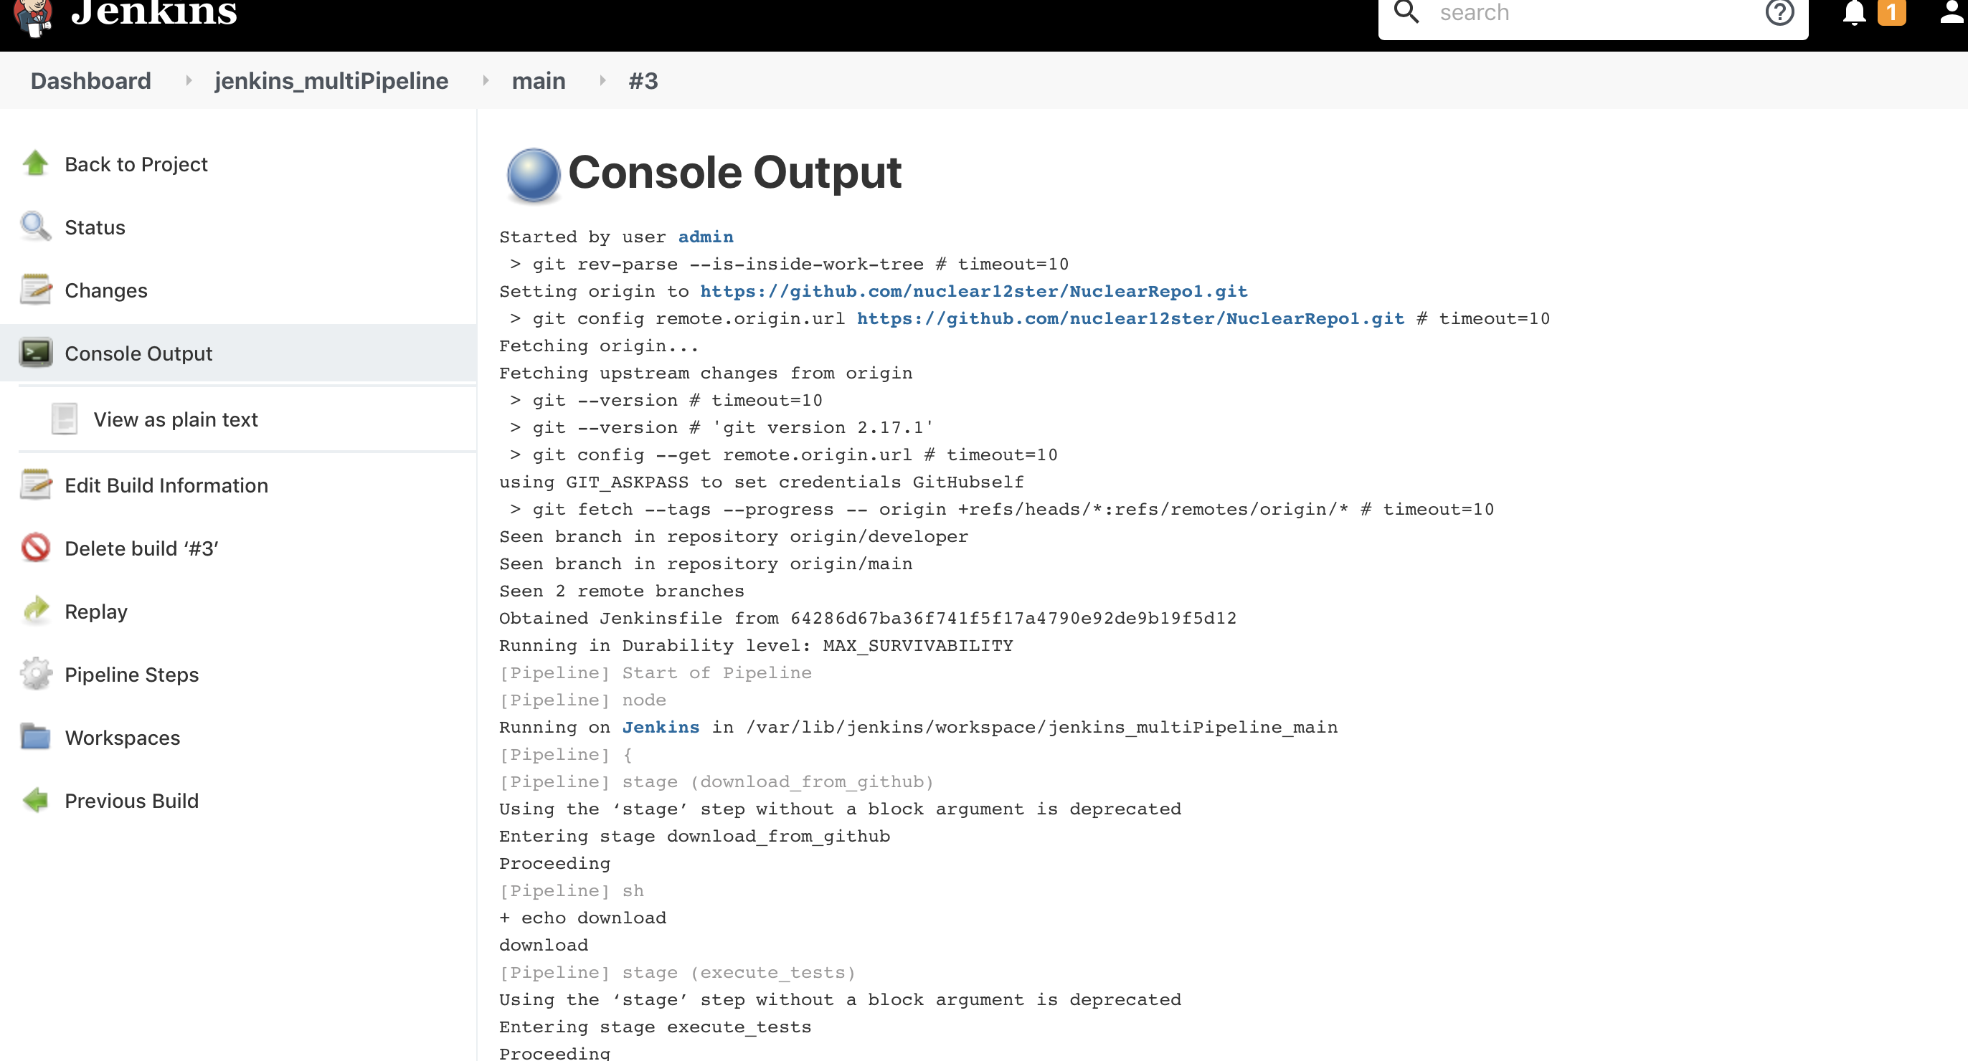

Create the Jenkinsfile in the develop branch too and build the project

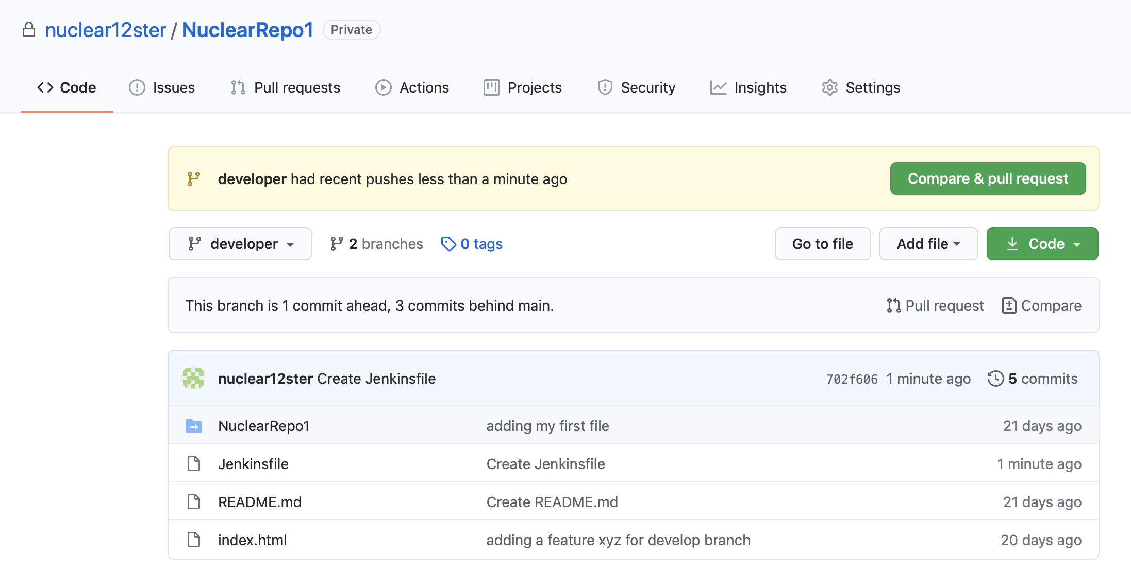

Now Jenkins created the 2 branches.

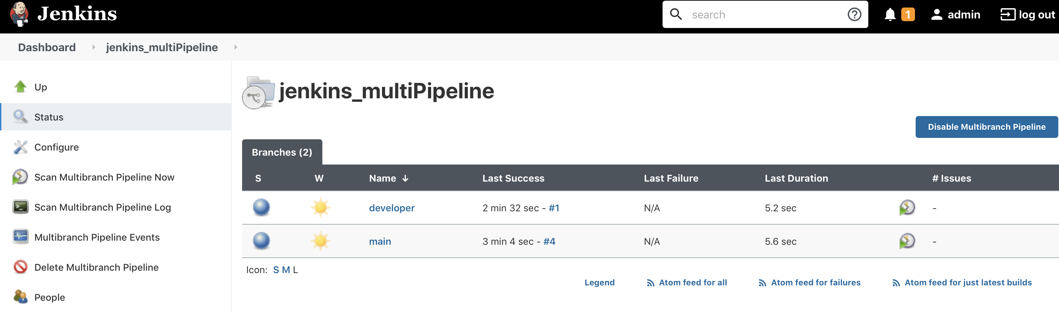

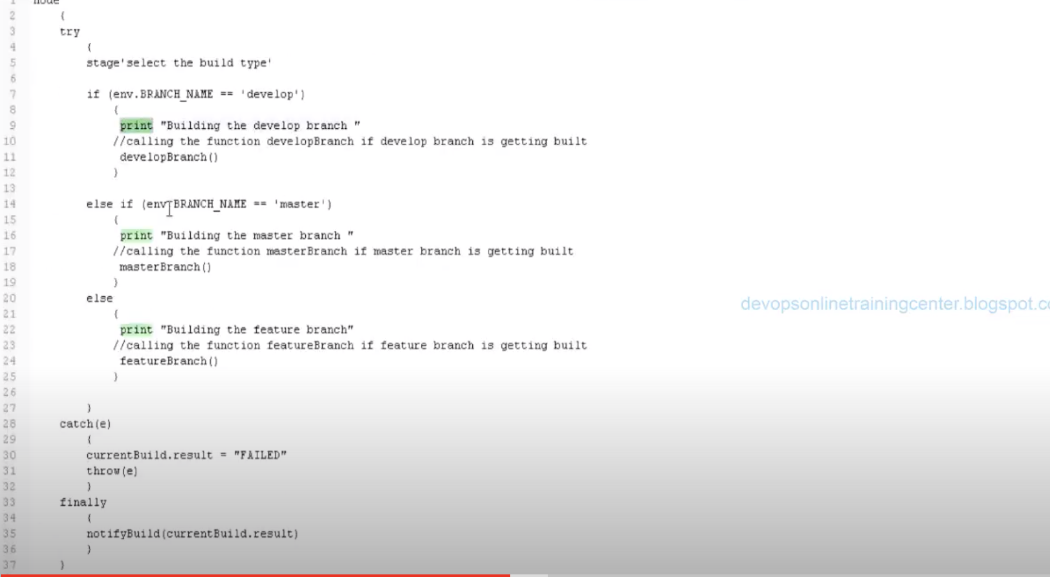

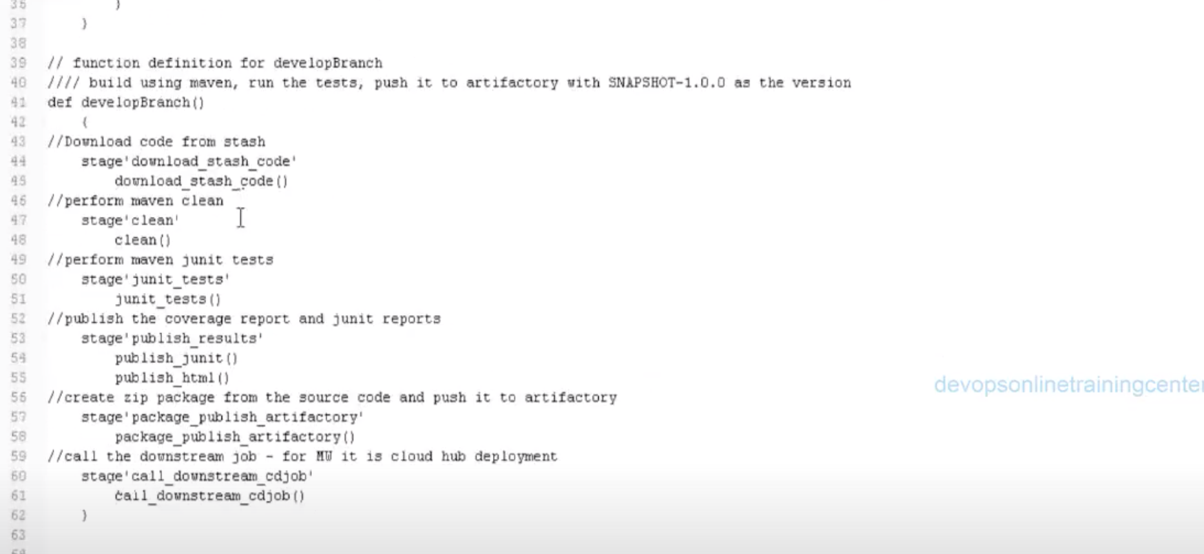

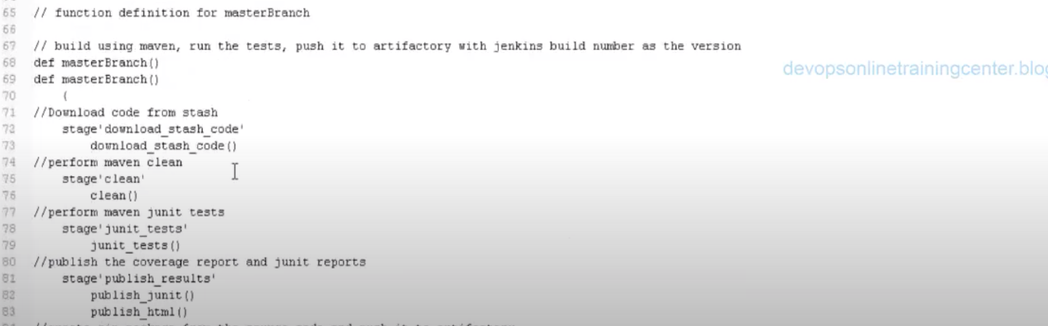

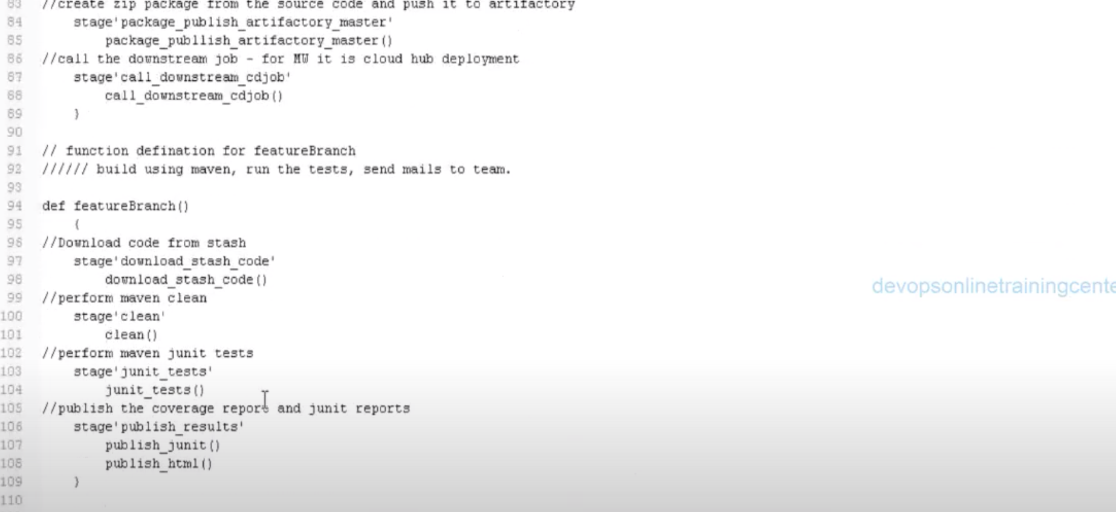

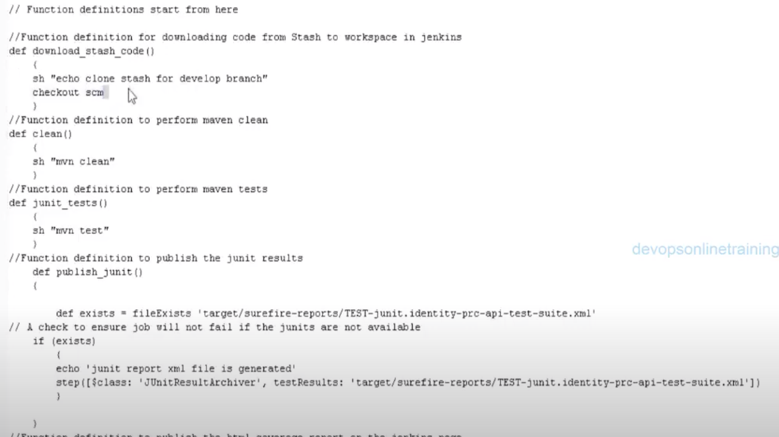

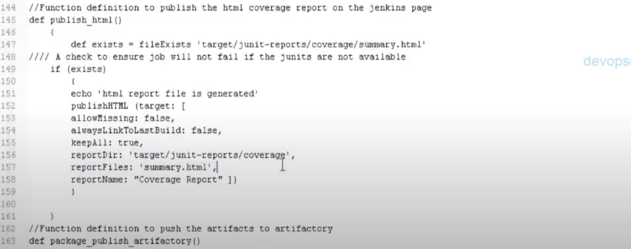

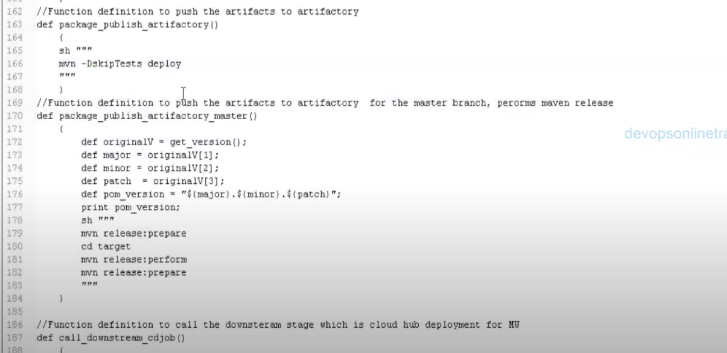

Send mail plugin and dns set up and proper networking.

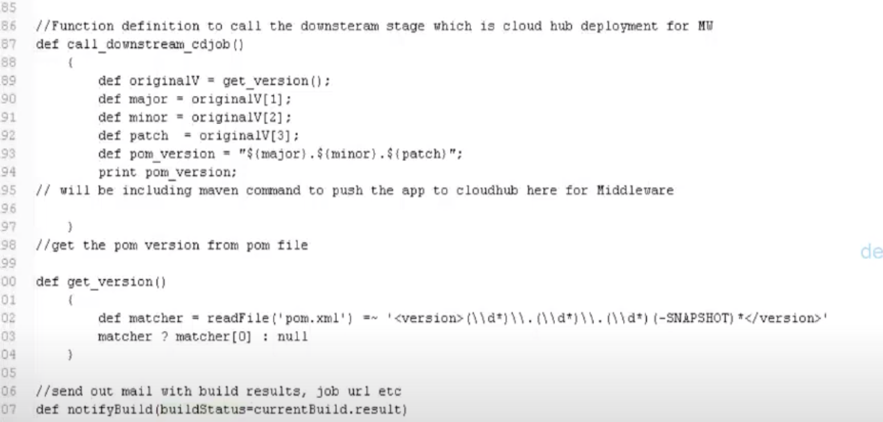

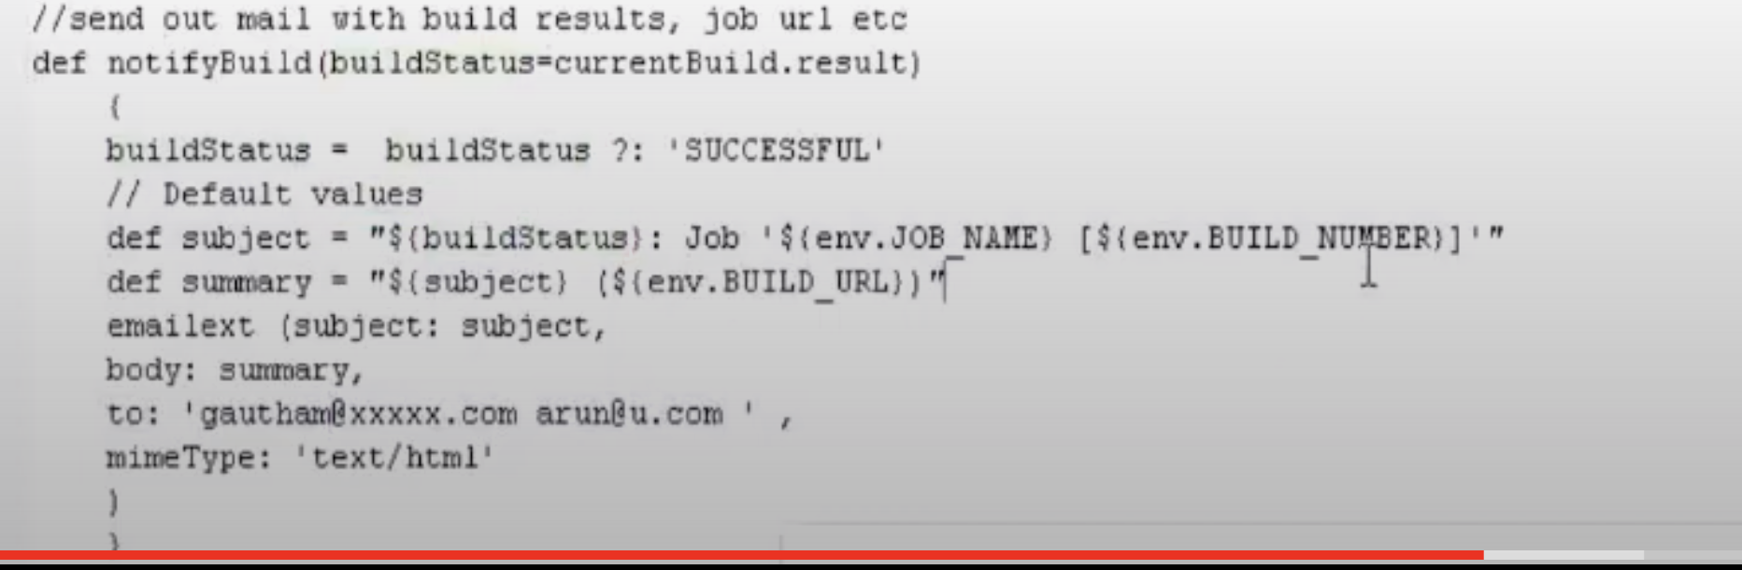

When polling should require time interval, and its start the execution automatically.

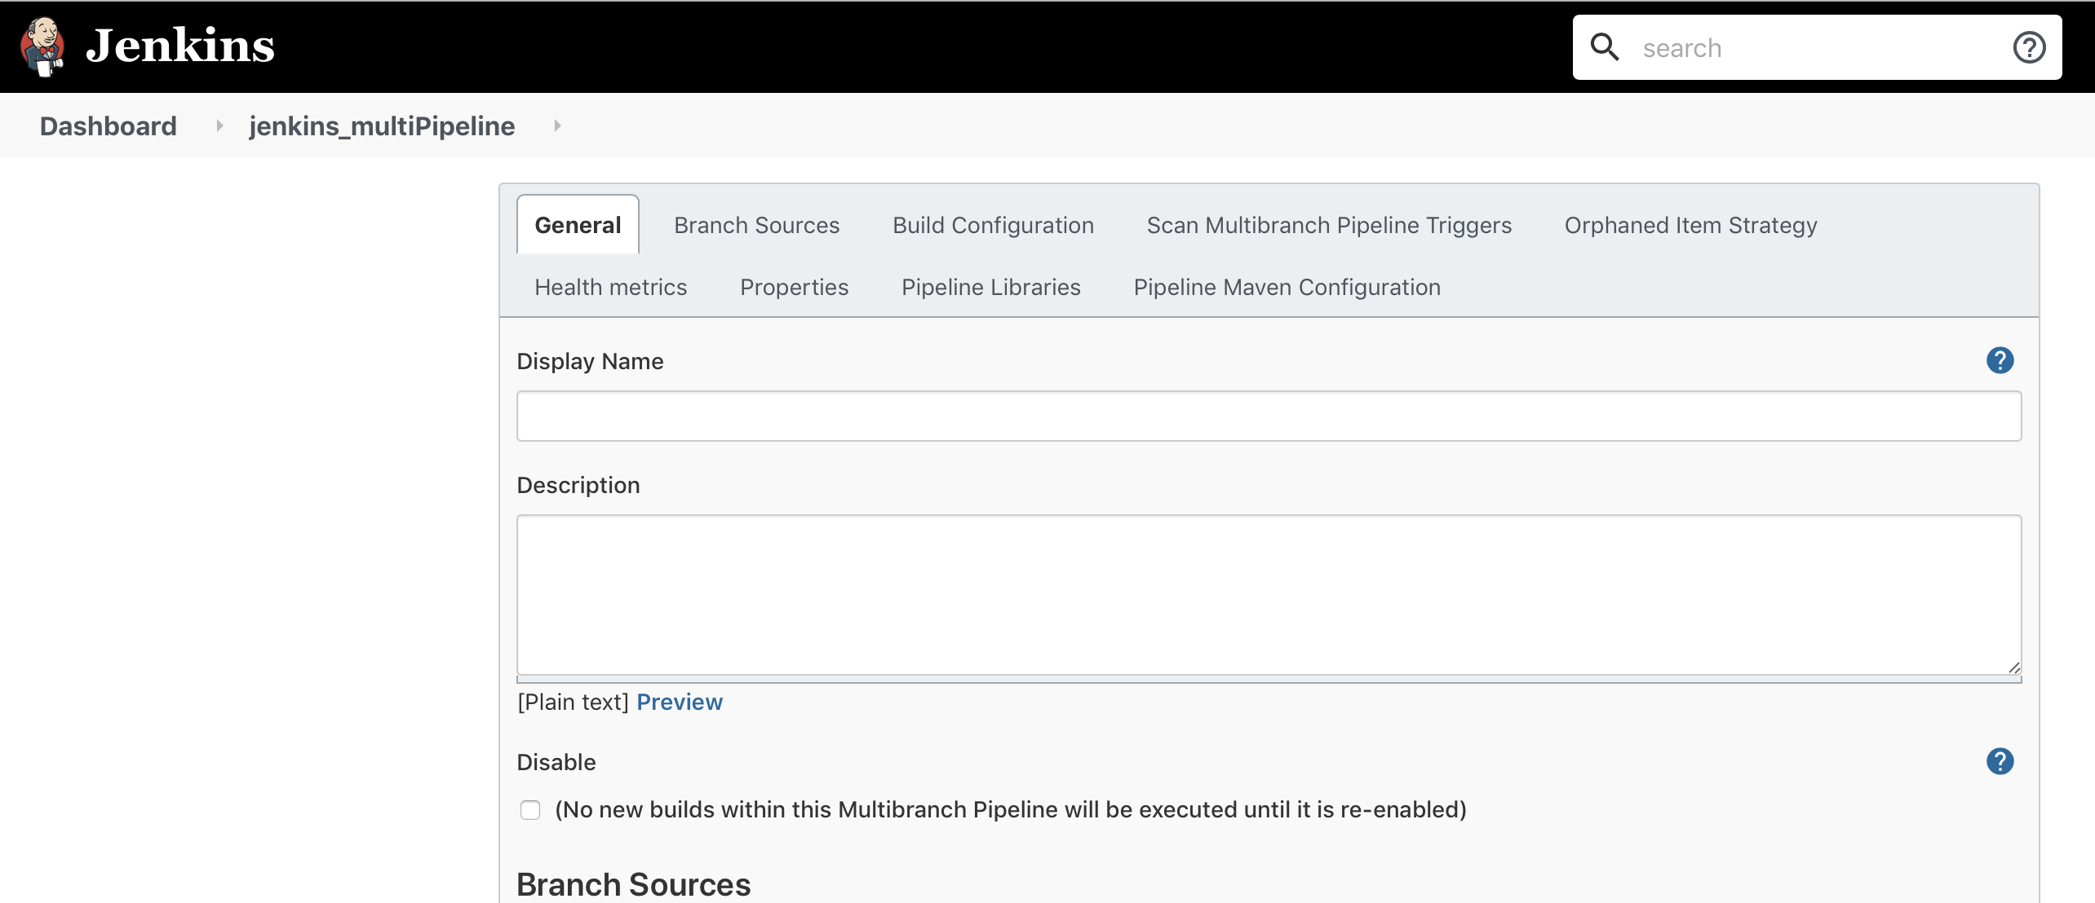

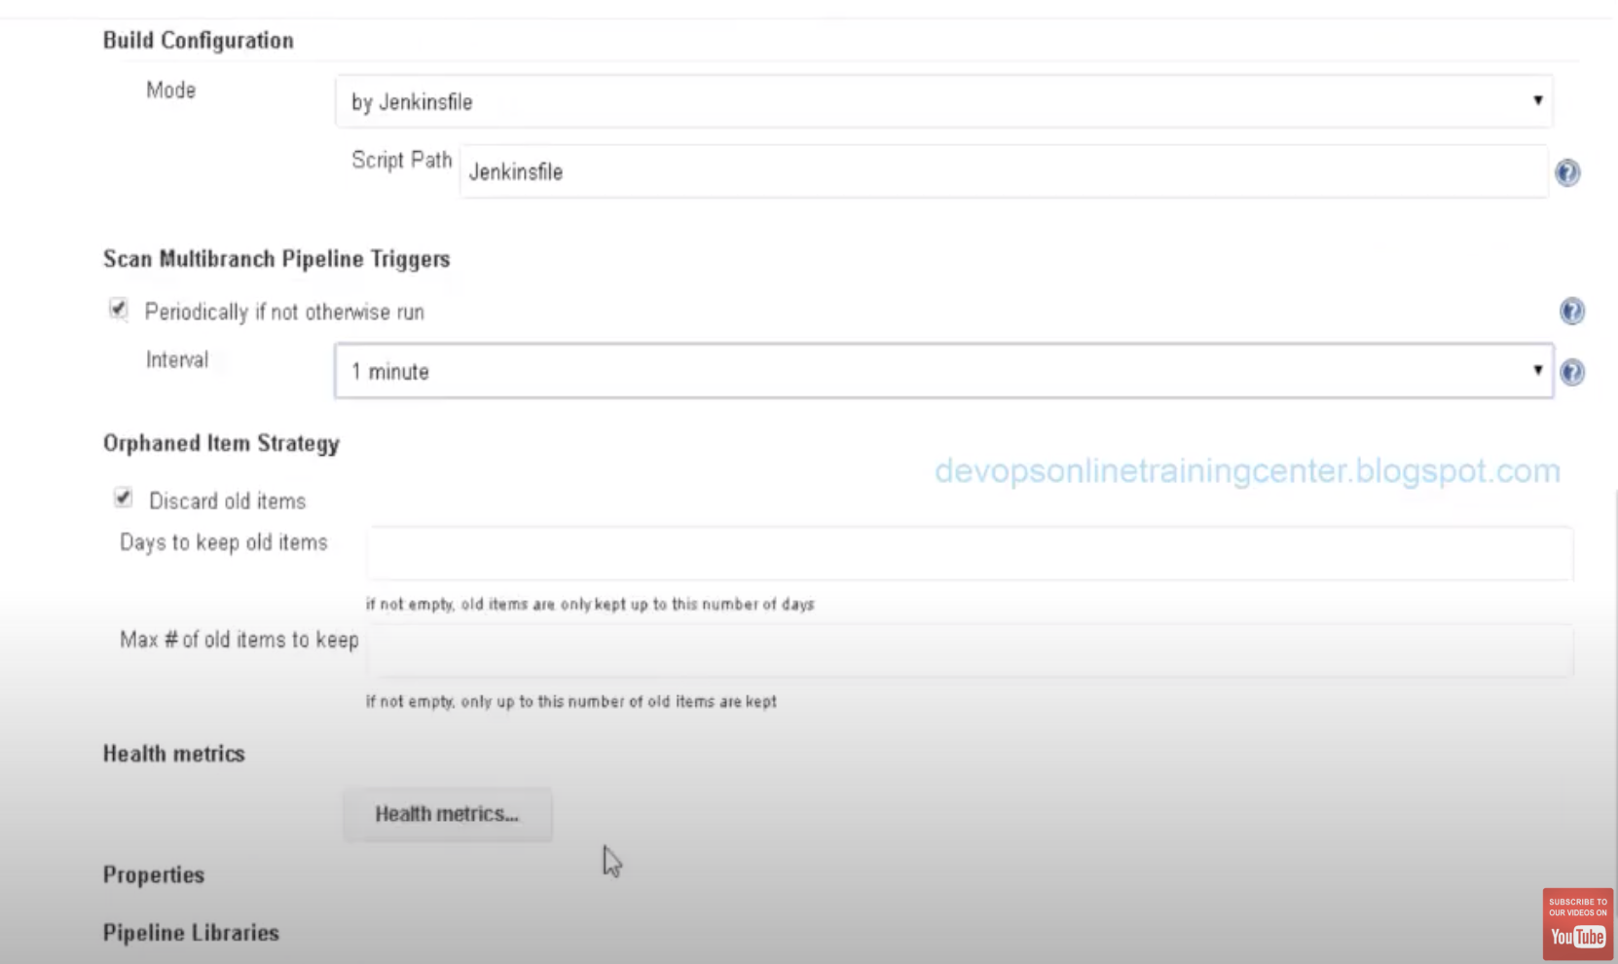

It will run automatically after 1minute when there is changes in Github file.

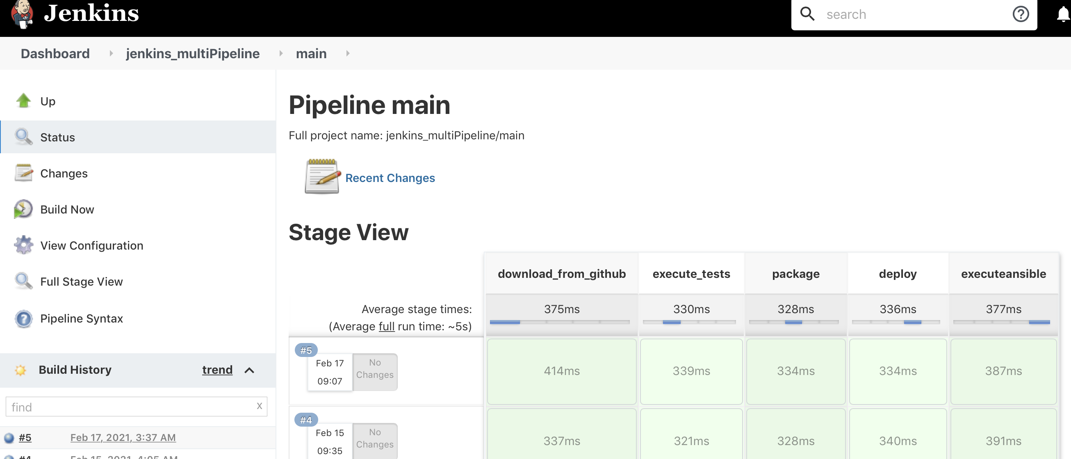

We can also provide input step to proceed further or not in jenkinsfile.

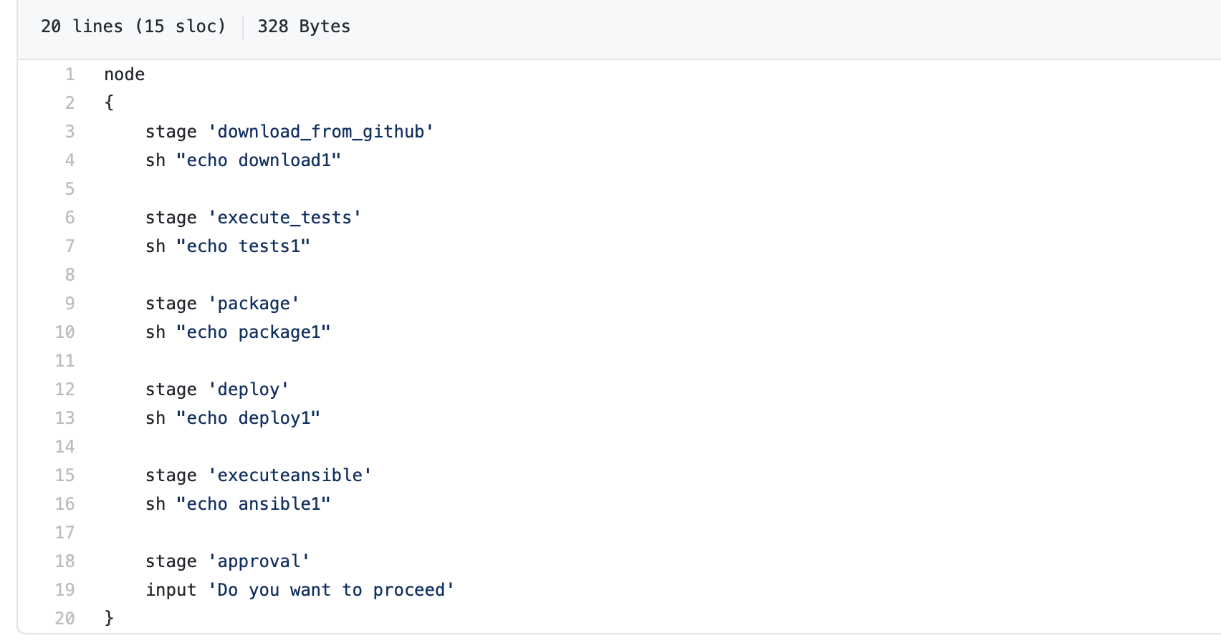

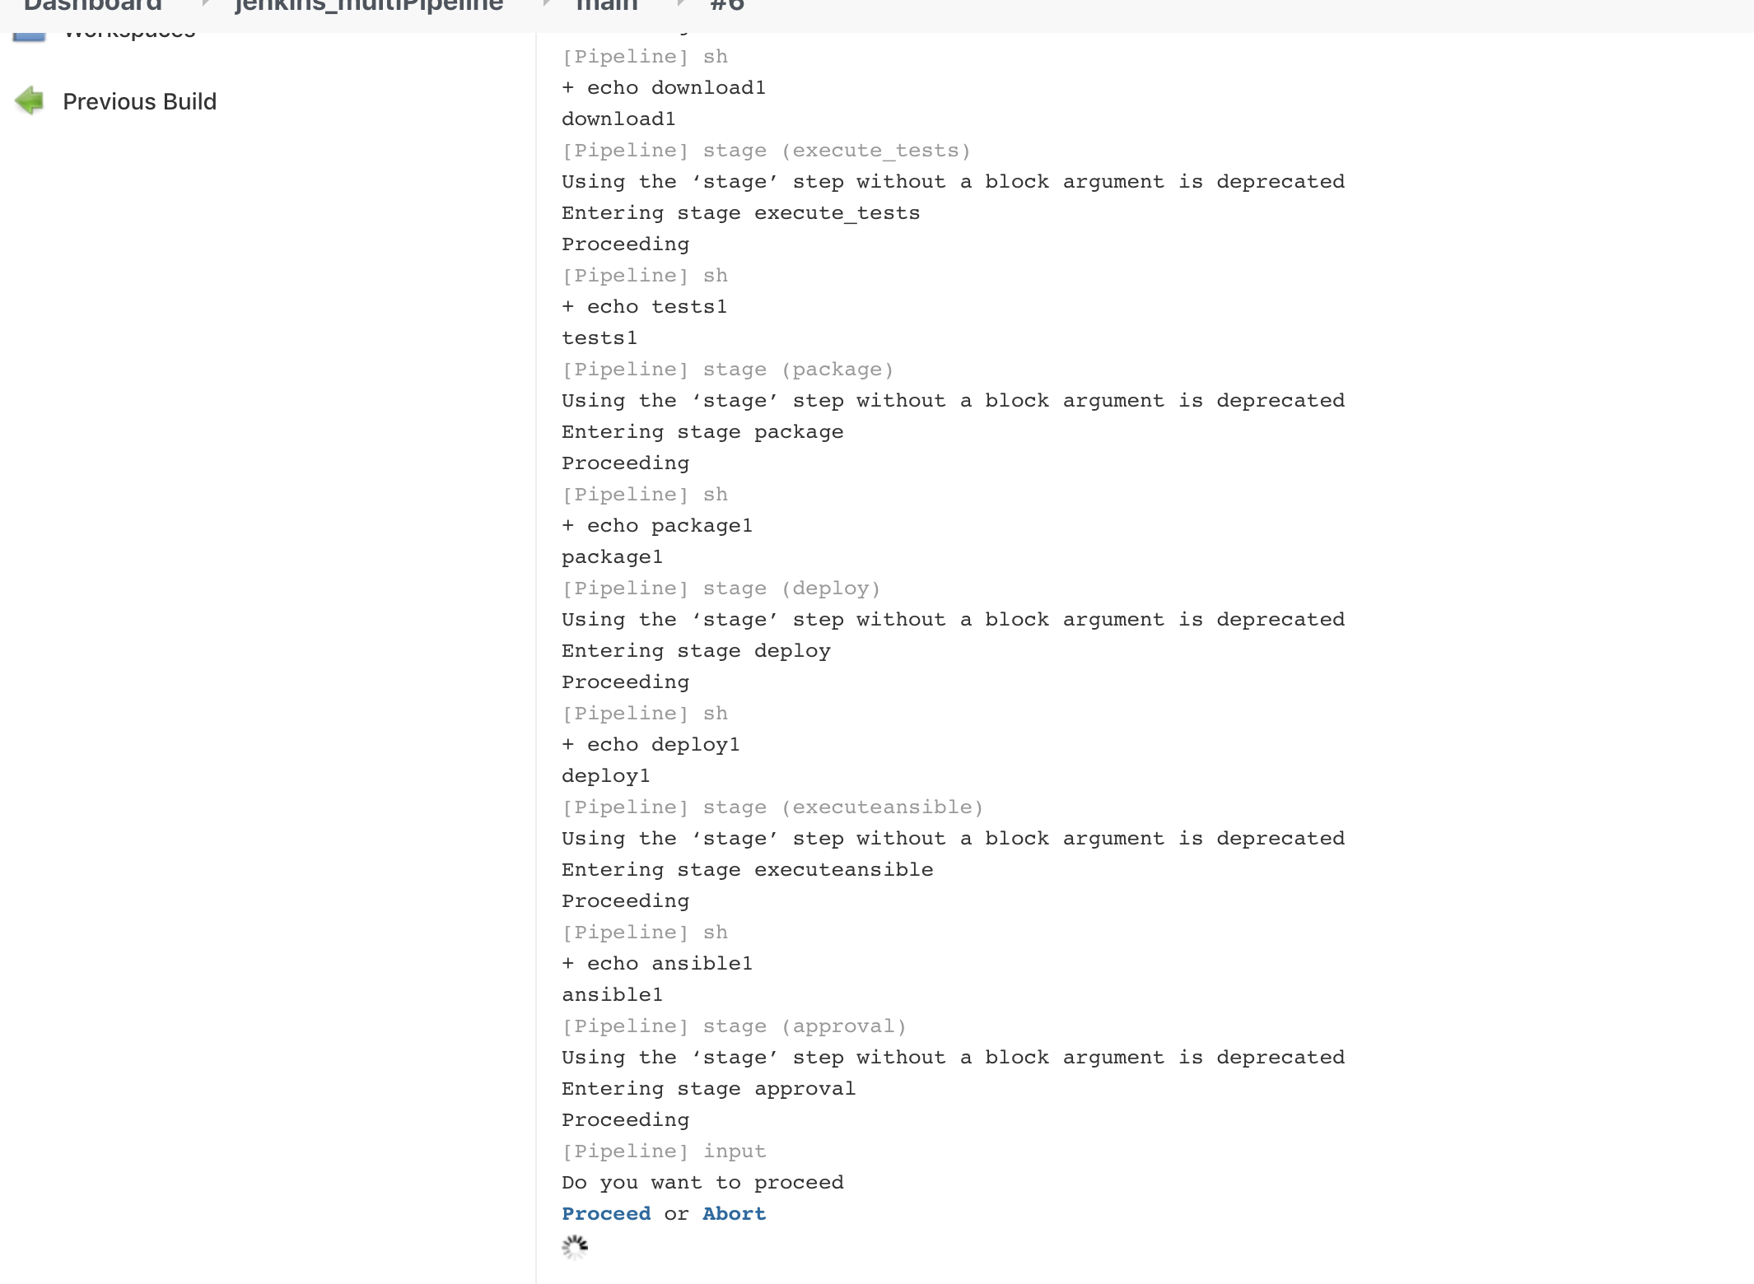

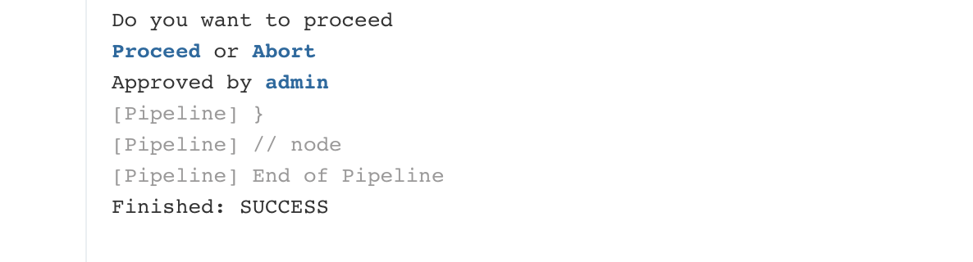

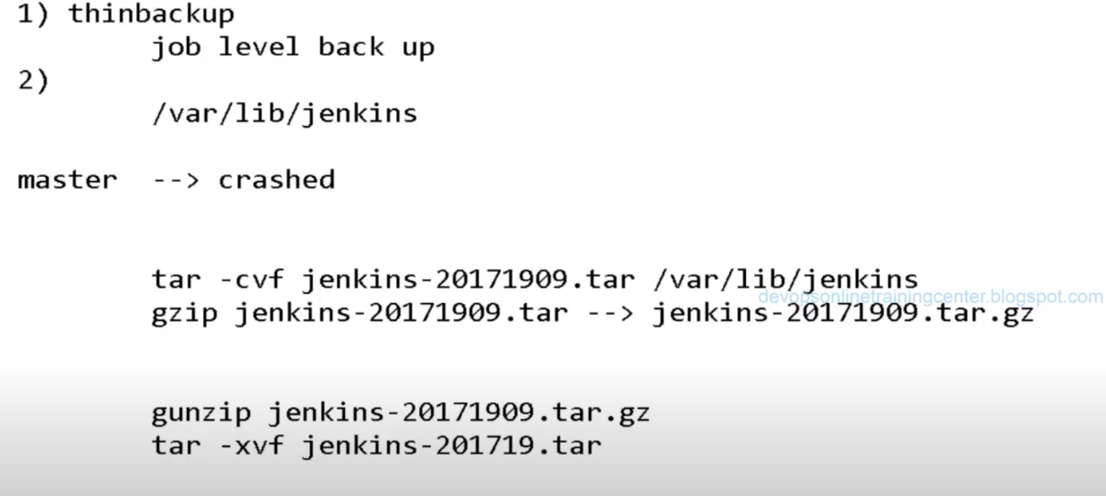

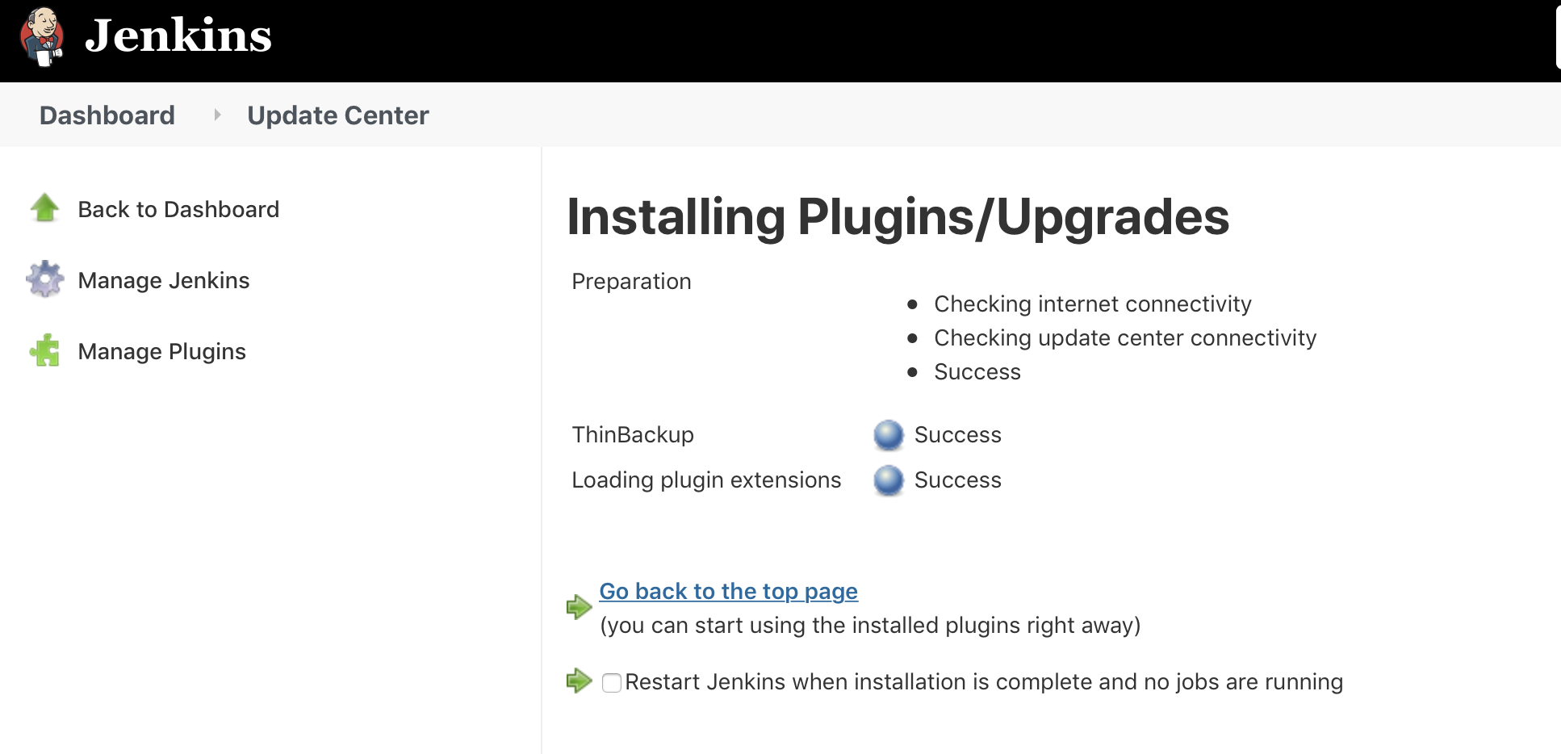

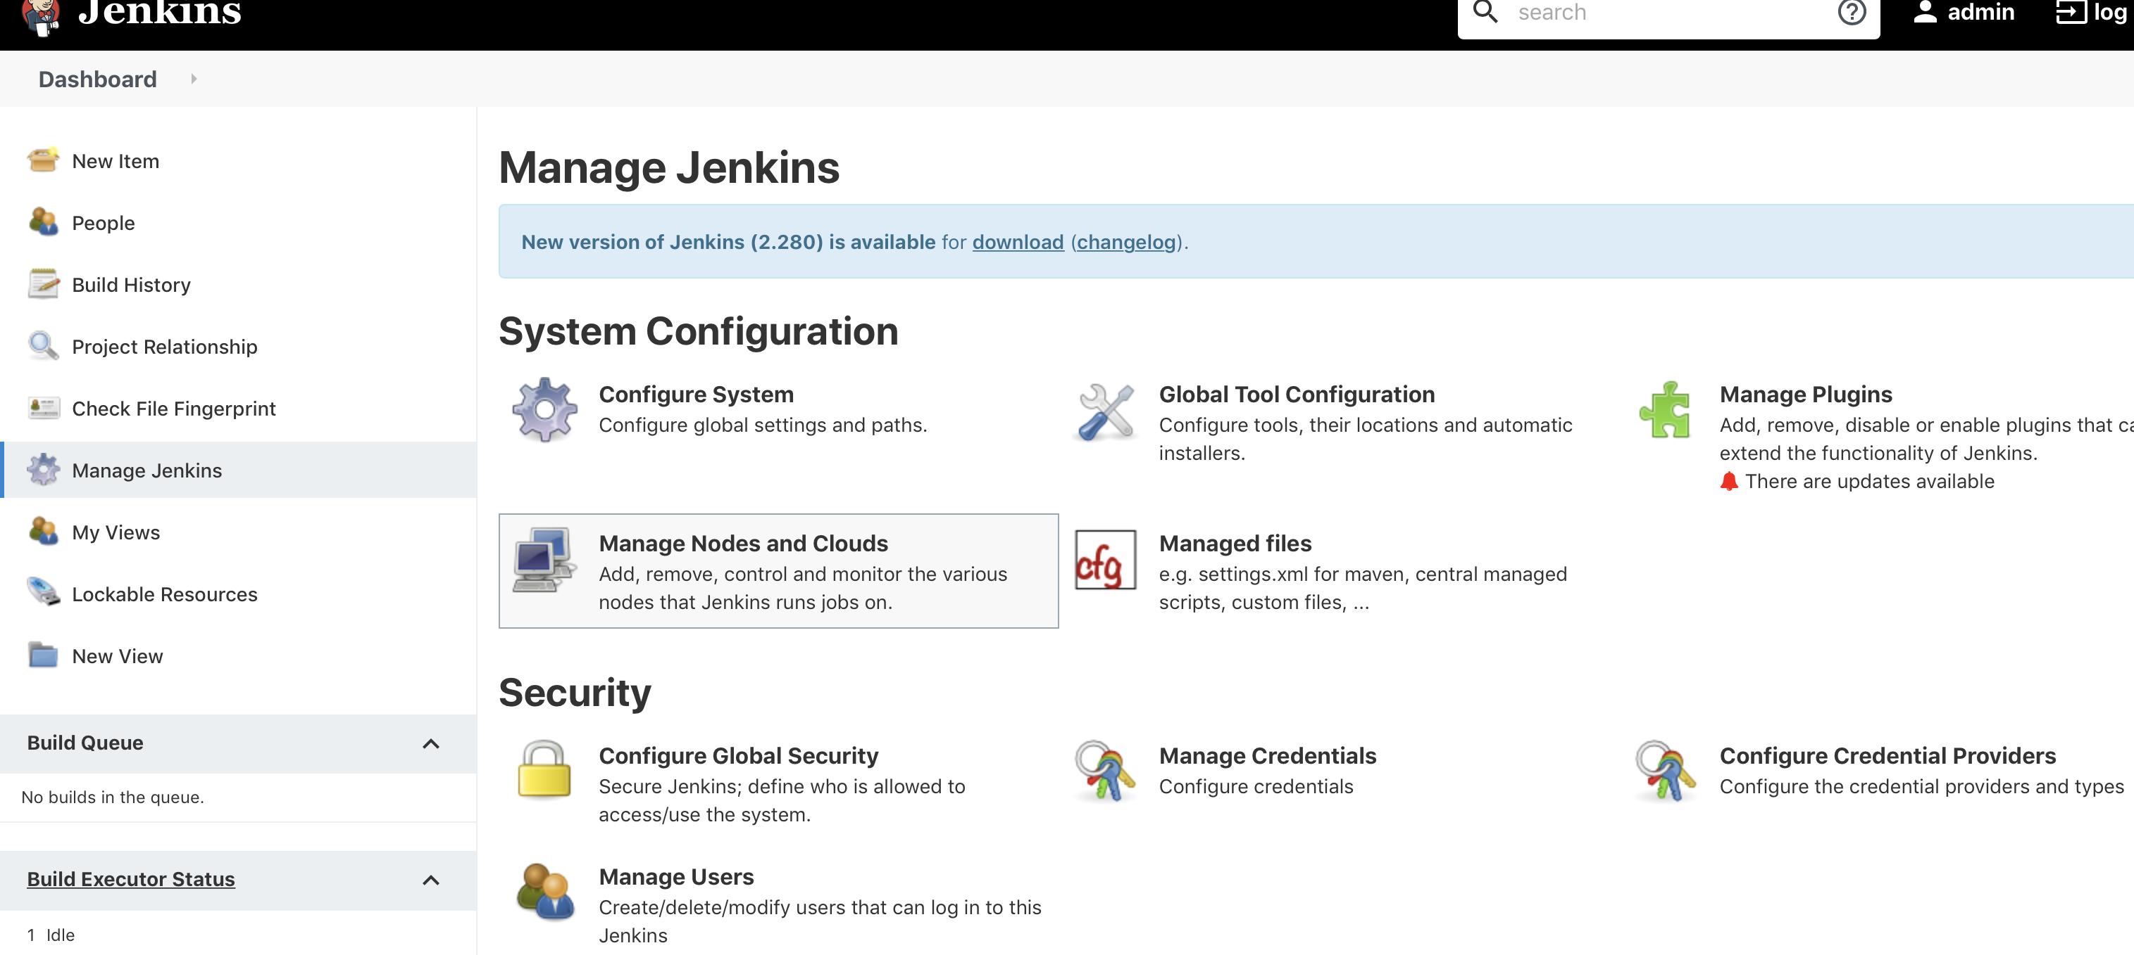

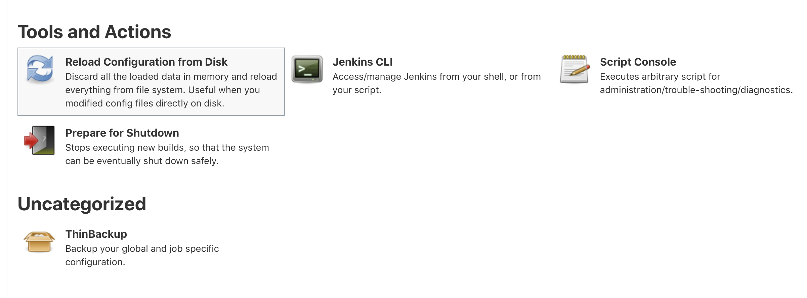

Click on “Backup Now” button below: It will take back-up of your Jenkins job.

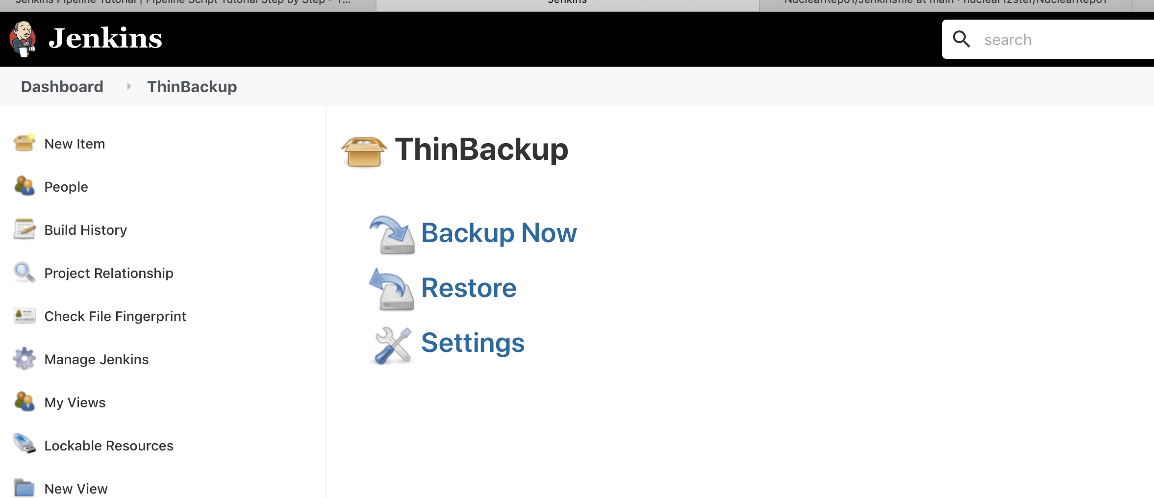

Click on Settings and specified the location where you want to take backup.

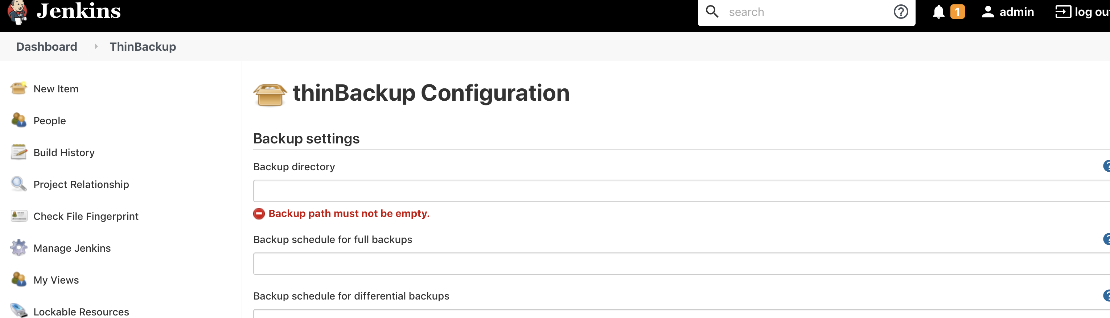

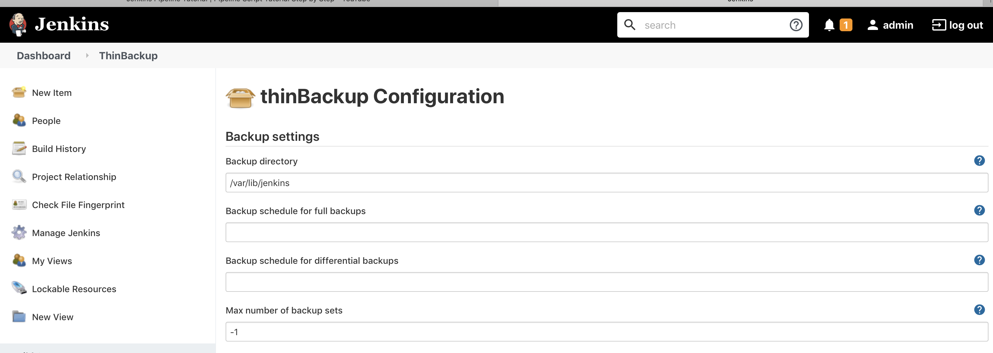

Then Click Save button.

Do some changes in any Jenkins job, save it and then restore.

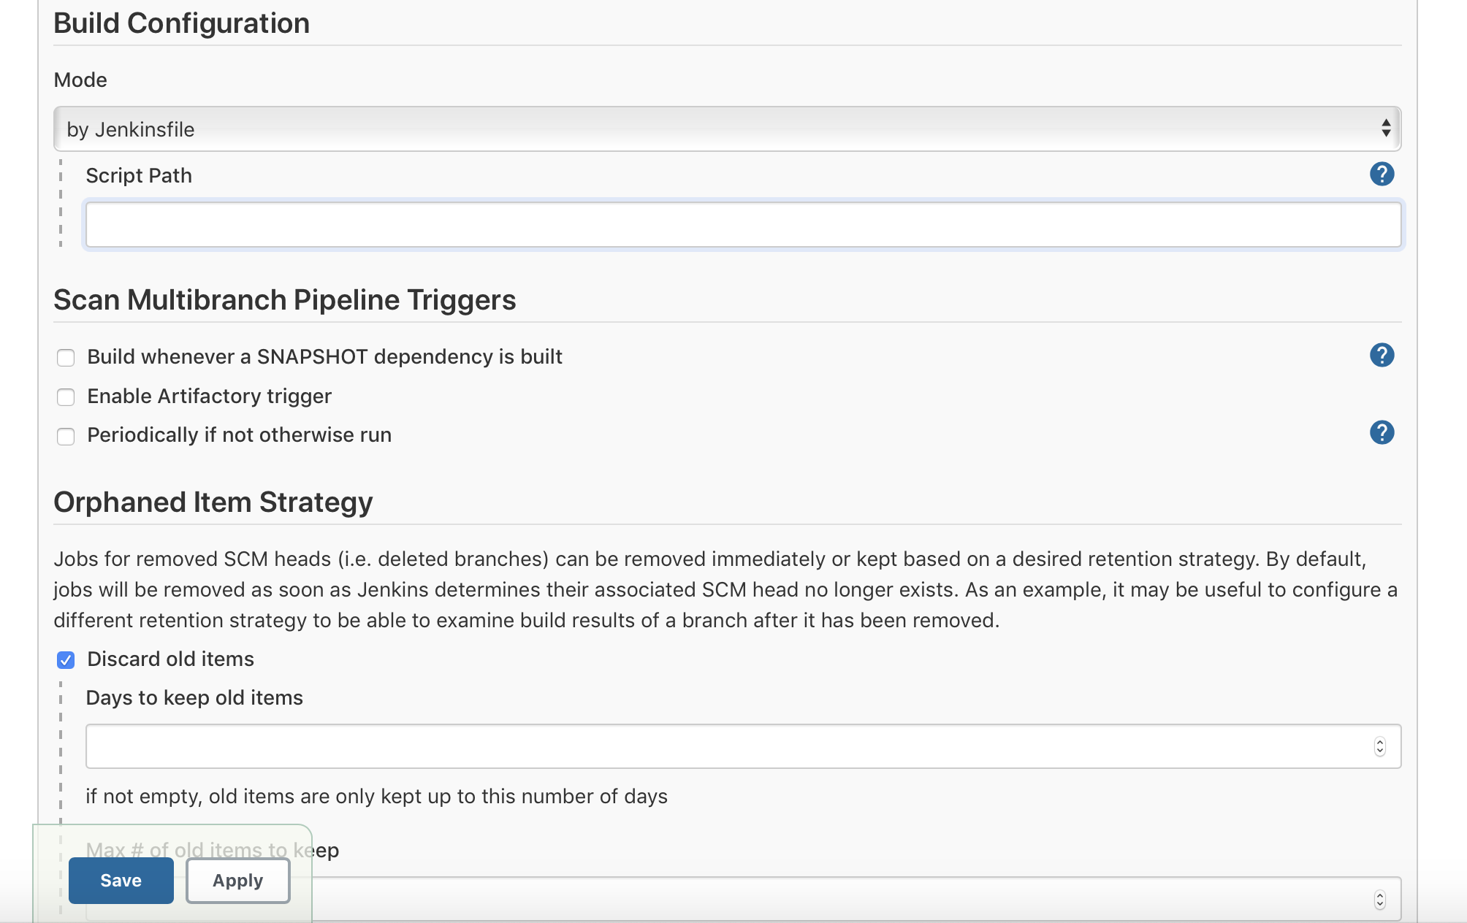

Now click take back up and then click Restore button, it will show the different time where you need to “restore backup from”. We can take multiple back-up of jobs and below option,

It will provide the date & timestamp for which we want to restore.

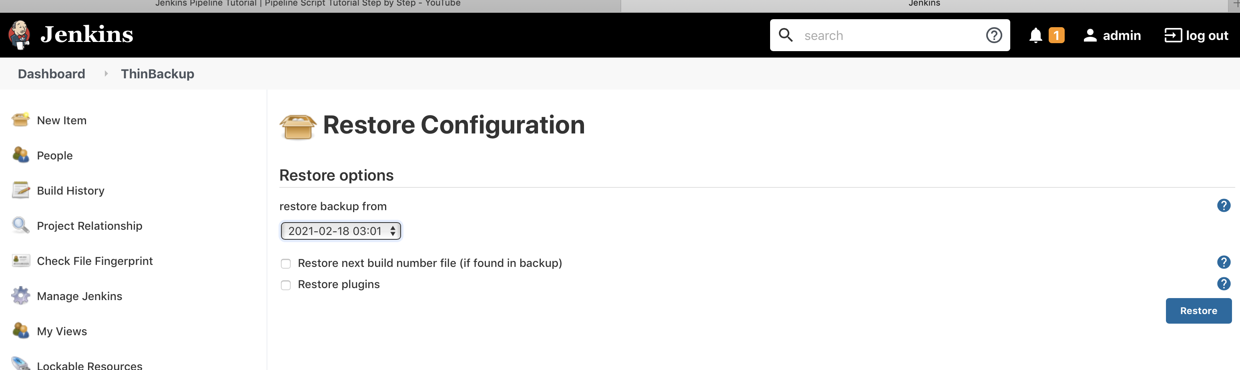

After Restore, it will bring back the jobs in original state.

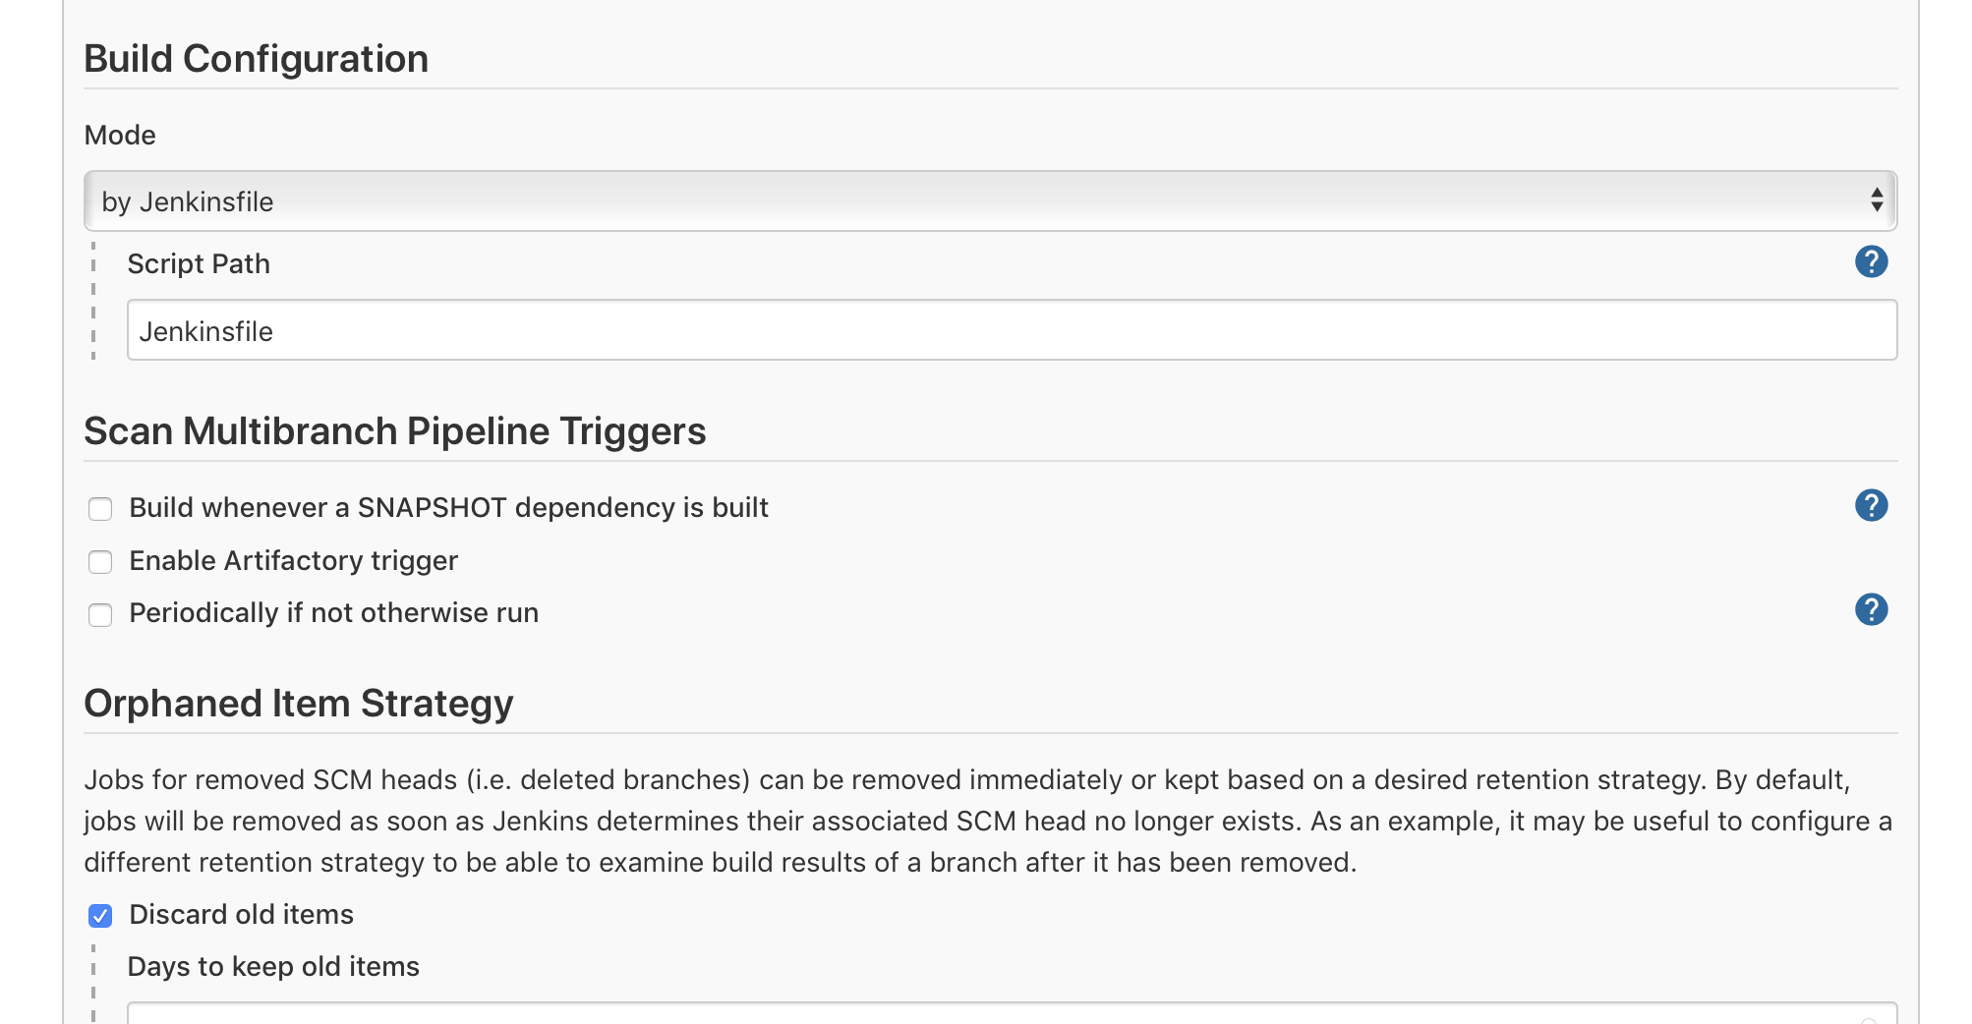

192.168.33.10:8080/job/Jenkins_multiPipeline/config.xml

It is available in the workspace also, just make a back-up of it and replace it with workspace’s config.xml, incase of any failure due to config.xml

